Lesson 2 Spain in America

ESSENTIAL QUESTION
What are the consequences when cultures interact?

GUIDING QUESTIONS
- What were the goals of early Spanish explorers?
- What led Spanish explorers to Florida?
- Why did Spain explore and colonize the American Southwest?
Terms to Know
Conquistador Spanish explorer
immunity resistance
pueblo a town and center of trade in Spanish America
mission a Spanish community for the religious conversion and training of Native Americans presidio a fort in Spanish America
plantation a large farm

Where in the world?
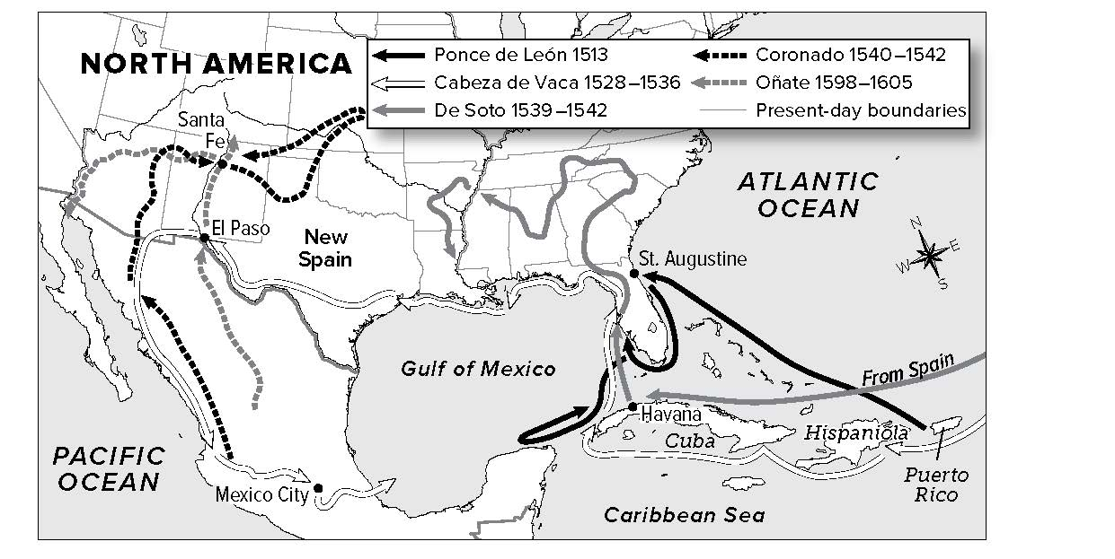

When did it happen?
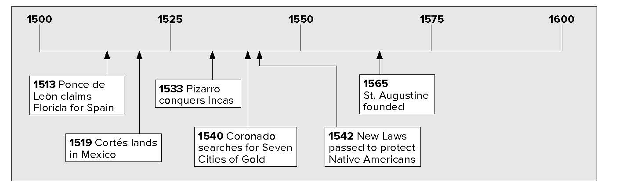

Lesson 2 Spain in America, Continued

Reading
Check
1. How were the Spanish able to conquer the Aztec and Inca Empires?

Explaining
2. Why did Juan Ponce de León come to Florida?

European Explorers and Conquerors
Early Spanish explorers were known as conquistadors, or conquerors. Their main goal was to find riches. Spanish rulers gave them the right to explore and settle in the Americas. In return they gave the rulers part of the wealth they found.
The Aztec Empire was in the area that is present-day Mexico and Central America. The Inca Empire was in present-day Peru. Both of these empires were very wealthy.
Hernán Cortés was a conquistador. He landed on the east coast of Mexico in 1519. He conquered the Aztec Empire by 1521. Cortés took gold from the Aztec. He shipped great amounts of gold back to Spain.
In 1533 another conquistador, Francisco Pizarro, led an army into the Inca capital city of Cuzco. He killed the Inca leader and took control of the Inca Empire.
Spanish armies were much smaller than the Aztec or Inca armies. Still, they won. There were three main reasons for this:
- The Spanish had numerous weapons, many of which Native Americans had never seen.
- Many Native Americans helped the Spanish fight their Aztec rulers.
- Native Americans were weakened by European diseases for which they had no immunity, or resistance.

Spain in Florida
Not all conquistadors would find the riches that Cortés and Pizarro found in the Americas. In 1513 Spanish explorer Juan Ponce de León came ashore in Florida. He claimed the land for Spain and called it “La Florida.”
Ponce de León was looking for gold. He was also looking for something else. He had heard stories about a fountain of youth. The story said that drinking water from it “Makes old men young again.” He never found the fountain.
The Spanish king made Ponce de León governor and asked him to start a settlement in Florida. Native Americans who lived in the area attacked the settlers. Many died, including Ponce de León.
In 1528 Pánfilo de Narváez came to Florida to start a colony. He was attacked by Native Americans in the Tampa Bay area. They had to flee by boat across the Gulf of Mexico.

Lesson 2 Spain in America, Continued

France heard about Spain’s riches in the Americas. They also wanted to control Florida. In 1562 Jean Ribault sailed to Jacksonville. He claimed Florida for France. Settlers built a fort along the St. Johns River called Fort Carolina.

Reading
Check
3. How did the Spanish respond to the French presence in Florida?
Explaining
4. What parts of the present-day United States were explored by Spaniards looking for the Seven Cities of Cibola?
Identifying
5. What did the Spanish build to protect their missions?
The Spanish king wanted to drive the French out of Florida. He made Pedro Menéndez de Avilés the governor of Florida and told him to start a colony. In 1565 he started the settlement of San Agustin (St. Augustine).
The French attacked the Spanish, but a hurricane sank their ships. The Spanish governor then attacked Fort Caroline. The French lost their foothold in Florida.

Exploring the Southwest
In search of riches, Spanish conquistadors also traveled to the area that became the Southwest part of the United States. Álvar Núñez Cabeza de Vaca was part of the group that came to Florida in 1528 with Pánfilo de Narváez. After they fled Florida, the survivors sailed across the Gulf of Mexico. They landed on an island near what is now Texas. Then they set off for Mexico.
Cabeza de Vaca talked about what he had seen and heard on his journey. He told about a place called the seven cities of gold or the “Seven Cities of Cibola.”
Many people heard about his stories and wanted to find the seven cities. One of them, Spaniard Hernando de Soto, led a group of explorers through what is now the southeastern United States. He stole food and supplies from Native Americans. In 1541 he crossed the Mississippi River. After reaching what is today Oklahoma, de Soto died from an illness.
Francisco Vásquez de Coronado also wanted to find the seven cities. He traveled through northern Mexico and present-day Arizona and New Mexico. He reached a settlement of Native Americans known as the Zuni (ZOO• nee) in 1541. He soon figured out that there was no gold in this area. His group then went west to the Colorado River and into what is now Kansas.
The Spanish had three types of settlements in the Americas—
pueblos, missions, and presidios.

Spanish Settlements
pueblo | town, trading center
mission | religious community; usually included a small town, farmland, and a church
presidio | fort near a mission

Lesson 2 Spain in America, Continued

Mark the Text
- In the text, underline the areas controlled by the Spanish in the 1600s.

Reading Check
- What generalization can you make about the Seven Cities of Gold?

8. Place a two-tab
Foldable along the dotted line to cover Check for Understanding. Write the title Searching for Riches on the anchor tab. Label the tabs Fountain of Youth and Seven Cities of Gold. Use both sides of the tabs to write two or more facts that you remember about each subject. Use your Foldable to help answer Check for Understanding.
There were different classes, or groups, in the Spanish settlements. People born in Spain were at the top. They were called peninsulares. The peninsulares owned the land. Below them were the creoles. Creoles were people born in the Americas who had Spanish parents. Below the creoles were the mestizos (meh • STEE • zohs). Mestizos had Spanish and Native American parents. Still lower were the Native Americans. They were often very poor. At the bottom were enslaved Africans.
In the 1500s, Spain forced Native Americans in certain areas to work as slaves. Many died from lack of food and disease.
Bartolomé de Las Casas was a Spanish priest. He helped to convince the Spanish government to pass the New Laws in 1542 to protect Native Americans.
Some settlers made money by sending crops and other goods to Spain. In the West Indies, the main exports were tobacco and sugarcane. The Spanish raised these crops on plantations
(plan • TAY • shuns). Plantations are large farms. The Spanish used Native Americans to work on the plantations. Later, traders would bring millions of Africans from West Africa. They would sell them to plantation owners and force them to work as slaves.
By the 1600s, the Spanish controlled most of Mexico, the Caribbean, and Central and South America. They also controlled parts of the present-day United States. Other European countries wanted to set up colonies in North America. They included England, France, and the Netherlands.
When France claimed land around the mouth of the Mississippi River, Spain wanted to defend its empire. To do so, it settled present-day New Mexico, Arizona, and Texas.

Glue Foldable here

Check for Understanding
What were the goals of the Spanish conquistadors?

What was the first Spanish settlement in Florida?

