Lesson 3 Competing for Colonies

ESSENTIAL QUESTION
What are the consequences when cultures interact?
GUIDING QUESTIONS
- What were the religious motives behind the Age of Exploration?
- How did French and Dutch settlements compare to the Spanish colonies?

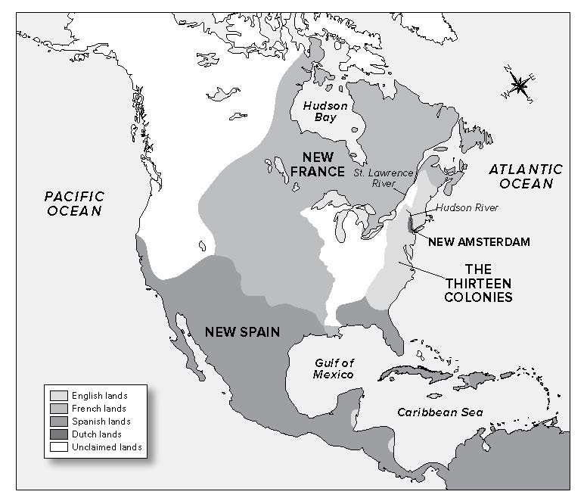
Where in the world?
Terms to Know
Reformation a sixteenth-century religious movement rejecting or changing some Roman Catholic teachings and practices and establishing the Protestant churches
Protestantism a form of Christianity that was in opposition to the Catholic Church
armada a fleet of warships
northwest passage a sea passage between the Atlantic and the Pacific along the north coast of North America
tenant farmer settler who paid the landowner an annual rent and worked for that lord for a fixed number of days each year
N
S

When did it happen?
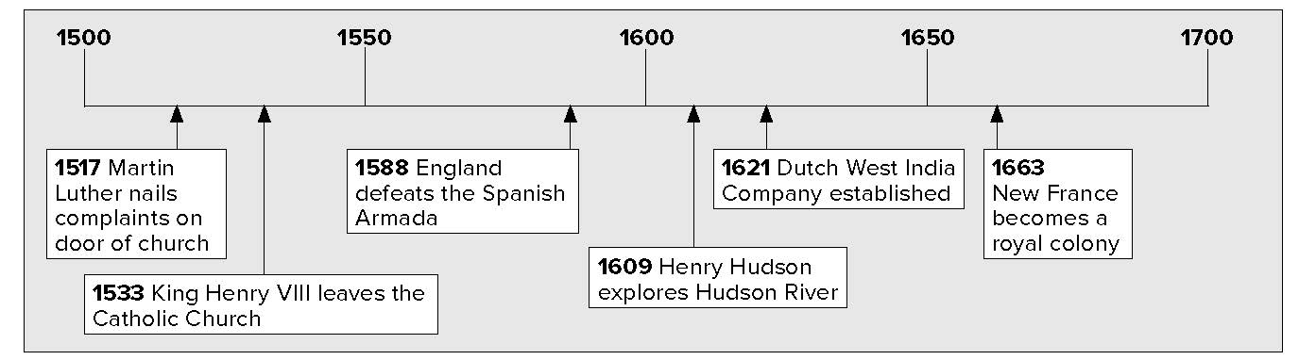

Lesson 3 Competing for Colonies, Continued

Religious Rivalries

Determining
Cause and Effect
1. What was a major cause of conflict between England and Spain in the 1500s?

Explaining
2. What event allowed England to start setting up colonies in North America?

Reading Check
3. Why did European nations want to find a northwest passage?
One reason for exploring the Americas was to spread the Christian religion. The first explorers were Roman Catholics. In 1517 a new form of Christianity began.
Martin Luther was a German priest who did not agree with practices in the Catholic Church. In 1517 he nailed a list of complaints to the door of the local Catholic Church. The complaints questioned the power and the authority of Catholic leaders. These leaders included the pope. The pope was the head of the Catholic Church.
Luther wanted to make changes, or reform the Catholic Church. His ideas helped to start what is called the Reformation (reh • fuhr • MAY • shuhn). This movement led to a new type of Christianity called Protestantism (PRAH • tuhs• tuhn • tih • zuhm). Protestants did not accept the pope as a leader. The Reformation caused conflicts between many European nations.
In 1533 King Henry VIII of England left the Catholic Church. His daughter ruled later as Queen Elizabeth I. During her rule, England became a Protestant nation. The people were required to follow the Protestant religion. If they did not, they might lose their land and money.
The king of Spain, a Catholic, saw a chance to invade England. He wanted to wipe out the Protestant religion there. The king sent an armada, or war fleet, to attack England. The fleet was huge. It was the strongest naval force in the world. The English fleet was smaller but faster. The British defeated the Spanish in 1588.
Spain no longer ruled the seas. The English decided it was time to set up colonies in North America. English and Dutch settlers were Protestant. They set up colonies along the Atlantic coast. Spanish settlers were Catholic. They settled in southwestern and southeastern North America. The French were also Catholic. They settled in the northeast. Religious differences caused conflicts between the colonies.
Explorers mapped the coast of North America. They set up colonies and traded with the Native Americans. Explorers also wanted to discover a direct water route through the Americas to Asia. They called this the northwest passage. Many explorers looked for it and found other things instead.

Lesson 3 Competing for Colonies, Continued

Listing
4. Which countries sent explorers to find a northwest passage to Asia?
Reading
Check
5. What were France’s main interests in North America?

Searching for the Northwest Passage
Explorer | Country | Year | Found Instead
John Cabot | England | 1497 | Probably present-day Newfoundland
Giovanni de Verrazano | France0 | 1524 | Explored coast of North America from Nova Scotia to the Carolinas
Jacques Cartier | France | 1535 | Sailed up St. Lawrence River, named the mountain at the site of modern Montreal
Henry Hudson | Netherlands | 1609 | Discovered Hudson River, sailed as far north as Albany; later discovered Hudson Bay

French and Dutch Settlements
French explorers and settlers did not come to the Americas until many years after Spain. At first, the French mainly wanted to find fish and furs. French trappers went far into the interior of North America. They traded with Native Americans. France built forts to protect its trade. French missionaries followed the traders.
In 1663 New France became a royal colony. The king named a governor for the colony. The governor encouraged more French exploration in North America.
In the 1670s, fur trader Louis Joliet and priest Jacques Marquette explored the Mississippi River by canoe. They turned back when they discovered that the Mississippi flowed south into the Gulf of Mexico and not west to Asia.
In 1682 Robert Cavelier de La Salle followed the Mississippi River. He went all the way to the Gulf of Mexico. He claimed the region for France. He called it Louisiana, in honor of King Louis
XIV. In 1718 The French started New Orleans. French explorers and missionaries also traveled farther west. They went all the way to the Rocky Mountains and the Rio Grande. They claimed all the territory for France.

Lesson 3 Competing for Colonies, Continued

The French were slow to settle in North America. New France was made up of estates along the St. Lawrence River. Estates are large areas of land with one owner. Estate owners brought in settlers to work the land. These tenant (TEH• nuhnt) farmers paid rent and worked for the owner for a set period of time. In exchange, the farmers could use the land to grow some of their own crops.

Mark the Text
- Underline the sentences that describe tenant farmers.

Describing
- How did the Dutch acquire the land for New Amsterdam?

8. Place a one-tab
Foldable along the dotted line to cover Check for Understanding. Draw a large oval on the tab and label it Religion in North America. Next, draw two smaller circles inside the large oval. Label the small circles Catholic and Protestant. Use the space inside the circles to list the countries of each religion that established colonies in North America. Use your Foldable to help answer Check for Understanding.
The French got along well with the Native Americans. French trappers and missionaries lived among them. The French learned their languages and respected the way they lived. The missionaries wanted to convert, or change, the Native American religion to Catholicism. However, they did not try to change their other customs. The French colony grew slowly. As a result, most Native Americans did not fear that the French would try to take their lands.
The Netherlands was a small country. It did not have many natural resources and only a small amount of farmland. That is why the Dutch wanted to set up a North American colony. After Hudson‘s trip in 1609, the Dutch began to explore North America.
The Netherlands had many trading ships that sailed all over the world. In 1621 the Netherlands started the Dutch West India Company. The company’s job was to run trade between the Americas and Africa. In 1623 the company took control of the Dutch colony in North America. It was called “New Netherland.”
New Amsterdam was the main town in the colony. It was built on the tip of Manhattan Island. In 1626 governor Peter Minuit bought the island from the group of Native Americans who lived there. They were called the Manhattoes. He paid them in trade goods worth 60 Dutch guilders (about $24).
Check for Understanding
What started the Protestant Reformation? What was the result of that action?

1.

2.
3. What were the French hoping to find as they explored
the Mississippi River?

