Lesson 1 Roanoke and Jamestown

ESSENTIAL QUESTION
How does geography influence the way people live?
GUIDING QUESTIONS
- What problems did the Roanoke settlers encounter?
- Why did the Jamestown settlement succeed?
Terms to Know
charter a document granting the recipient the right to settle a colony
joint-stock company a company in which investors buy stock in return for a share of the company’s future profits
headright a 50-acre grant of land given to settlers who came to the colony
burgess an elected representative to an assembly

When did it happen?
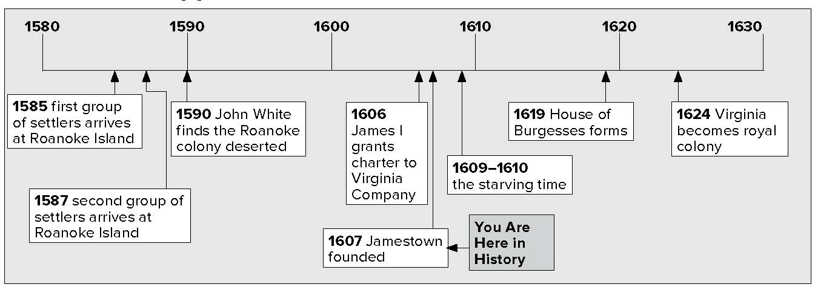

What do you know?
In the first column, answer the questions based on what you know before you study. After this lesson, complete the last column.

Now... |  | Later...
 | Who were the Powhatan?
 | Where was Jamestown located?

Lesson 1 Roanoke and Jamestown, Continued

The Mystery of Roanoke

Identifying
1. Who sent settlers to Virginia?
Mark the Text
- Circle the date the second group of settlers went to Roanoke Island.

Identifying Cause and Effect
- Why did John White return to England? Why did he not come right back?
________________

Speculating
4. What do you think happened to the Roanoke colonists?
________________

Reading Check
5. Why did the English decide to settle on Roanoke Island?
England wanted to settle some people on land it claimed in North America. England’s Queen Elizabeth gave Sir Walter Raleigh the right to start a colony there. Raleigh sent scouts to find a good place for the colony. They said Roanoke Island would be a good place. Roanoke Island is just off the coast of what is now North Carolina. The first settlers arrived in 1585. They had a rough winter and gave up and returned to England.

People Involved with Roanoke Colony
Person | What he or she did
Queen Elizabeth  Sir Walter Raleigh  John White  Virginia Dare | Gave Raleigh the right to start a colony  Sent scouts to find a location; sent settlers to Roanoke Island  Leader of Roanoke Colony  First English child born in North America

Raleigh sent settlers to Roanoke Island again in 1587. The
leader of this group was John White. His daughter went with
him. She soon had a baby named Virginia Dare. Virginia
Dare was the first English child born in North America.
The colony needed supplies, so White returned to England
to get them. He did not come right back, though. England
was fighting a war with Spain. All of England’s ships were
being used in the war. It took three years for White to get
back to Roanoke Island.
When White arrived back at Roanoke Island all the settlers
were gone. What happened to them? The only clue was a
word carved on a tree trunk. That word was Croatoan.
Maybe the word meant the settlers went to Croatoan Island.
No one knows for sure. They were never seen again.

Success at Jamestown
The Roanoke Colony failed. However, England still wanted a colony in North America. The English decided to try again.
England had a new king, James I. He gave a business
a “charter” to start a colony. A charter is a document that

Lesson 1 Roanoke and Jamestown, Continued

gives someone the right to start a colony. The name of the business that received the charter was the Virginia Company.

6. Place a one-tab
Foldable along the dotted line to cover the text that begins with “The Virginia Company was a joint- stock company.” Label the anchor tab Virginia Company. Write Making Money in the middle of the tab.
Draw three arrows around the title. List words or phrases that explain how investors felt they would make money by investing in the Virginia Company.
Mark the Text
7. Circle the date the settlers built Jamestown.
Identifying
8. Who forced the settlers to work? Who helped the colonists?
Glue Foldable here
The Virginia Company was a joint-stock company. This meant that many people each owned a small part of the company. If the company made money, each owner would get part of the money the company made.

Why is it called a joint-stock company?
Joint means “together.” All of the owners owned the Virginia Company together. Stock is the word for the part of the company each person owned.

The people who each owned stock, or small parts, of the Virginia Company, wanted to make money. They hoped that a colony in North America would make money for the company. How? They thought the colonists would find gold, or collect and sell furs and fish.
The Virginia Company sent 144 settlers to North America.
They sailed from England, across the Atlantic Ocean, and to the coast of North America. They sailed up a river and on its bank built a tiny town in 1607. They named the river the James River. They named their town Jamestown. Both names were to honor King James.
Life was difficult in Jamestown. The colonists suffered from disease and hunger. Captain John Smith forced the settlers to work. He also made friends with the local people. They were Native Americans called the Powhatan. Their chief was also named Powhatan. He gave the colonists food and helped them survive.
Then, things got worse. The colonists and the Powhatan stopped getting along. Powhatan stopped giving the colonists food. The winter of 1609–1610 was called “the starving time.” Many colonists died.
Soon after that, new colonists arrived. The colony started to do well. The colonists started growing and selling tobacco. This made money for the owners of the Virginia Company. Then, things got even better. A colonist named John Rolfe married a Powhatan woman. Her name was Pocahontas, and she was the chief’s daughter.

Lesson 1 Roanoke and Jamestown, Continued

Jamestown Succeeded For Many Reasons

Identifying
9. What was the purpose of the House of Burgesses?
10. Who did the burgesses
represent?
Reading
Check
11. Why was the House of Burgesses important?
12. Use a three-tab Venn diagram Foldable and write the title English Colonies on the anchor tab. Place it along the dotted line to cover the Check for Understanding. Label the tabs—Roanoke, Both, and Jamestown. On both sides of the tabs, list words and short phrases that you remember about each to compare the colonies. Use the Foldable to help do the activity below the tabs.
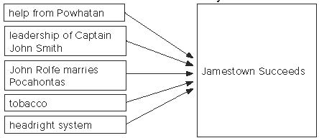

The Virginia Company wanted even more settlers to go to Virginia. They gave 50 acres of land free to each new settler who would go there. This land grant is called a headright. The headright system brought many new settlers to the colony.
At first, the Virginia Company and the leaders it appointed made the rules for the colonists. In 1619, the company began letting the colonists make some of the rules themselves. It allowed them to choose representatives called burgesses to make the rules for them. These representatives met in a group called the House of Burgesses. The House of Burgesses was the first legislature in North America to be elected by the people.

