Lesson 2 The New England Colonies

ESSENTIAL QUESTION
How do new ideas change the way
people live?

GUIDING QUESTIONS
- Why did the Puritans settle in North
America?
- What role did religion play in founding
the various colonies?
Terms to Know
dissent to disagree with an opinion
persecute to mistreat a person or group on the basis of their beliefs
tolerance the ability to accept or put up with different views or behaviors

Where in the world?
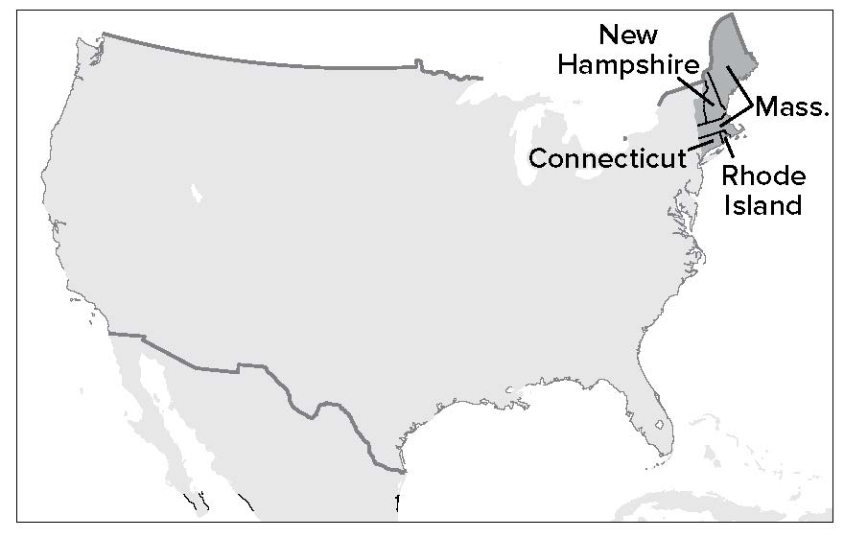

When did it happen?
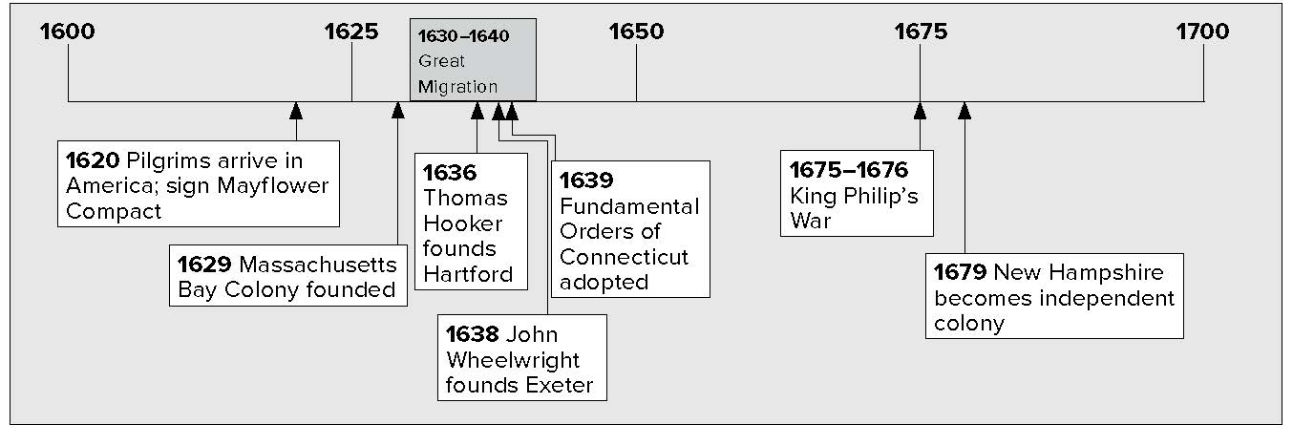

Lesson 2 The New England Colonies, Continued

Seeking Religious Freedom
Many English settlers came to North America to have religious freedom. In England, the main church was the official Anglican Church. The Anglican Church was a Protestant church. Many people who were Catholic did not want to practice the Anglican religion. Even many Protestants were unhappy with the Anglican Church. They dissented, or disagreed with, what the church was doing. Members of the Anglican Church who

Defining

- Write the definition of
dissent here.

wanted to change or “purify” it were called Puritans. Persons who wanted to leave the Anglican Church, or separate from it,
were called Separatists.

Making Connections
English religious groups in 1600s | Anglicans | members of Anglican Church
 | Puritans | wanted to change the Anglican Church
 | Separatists | wanted to separate from the Anglican Church
 | Catholics | members of Roman Catholic Church

- How did the Puritans get their name?

The Separatists were persecuted, or mistreated because of their beliefs. One group of Separatists fled to the Netherlands, but they were not happy there. They decided to start a colony in North America. This group is known as the Pilgrims. (A “pilgrim” is a person who makes a journey for religious reasons.) In 1620 the Pilgrims sailed to North America aboard a ship called the Mayflower. They landed at Cape Cod Bay in what is now Massachusetts. They named their colony Plymouth.
Before they went ashore, the Pilgrims signed an agreement to govern themselves. The agreement was called the Mayflower Compact. By signing it, they all agreed in advance to obey whatever laws they passed for their colony. The Mayflower Compact was an important step in the development of democratic government.
The people of Plymouth governed themselves for 70 years. Later, Plymouth became part of a nearby colony called Massachusetts.

Identifying

- Which Separatist group founded a colony in North America?

- What colony did this group found?

Lesson 2 The New England Colonies, Continued

Defining

- What is another word that has the same meaning as compact?

Identifying

- Name three ways that Squanto and Samoset helped the Pilgrims survive.

Reading Check

- Why is the Mayflower Compact an important document in American history?

Why was it called the Mayflower Compact?
The Pilgrims named their document the Mayflower Compact because they were on their ship the Mayflower when they signed it. Compact means “an agreement.” So the Mayflower Compact was an agreement signed on board the Mayflower.

At first life was very difficult in the Plymouth colony. Nearly half of the colonists died during the first winter. Then, in the spring, two Native Americans befriended the Pilgrims: Squanto and Samoset. They showed the Pilgrims how to grow corn and other crops and where to hunt and fish. The Pilgrims might not have survived without their help. Squanto and Samoset also helped the Pilgrims be accepted by other Native Americans nearby. In the fall of 1621, they all celebrated together in a great feast of thanksgiving.

New Colonies
In 1629 another colony was established nearby. This was the Massachusetts Bay Colony. It was founded by Puritans. The leader of the colony was John Winthrop.
In the 1630s, more than 15,000 Puritans left England
to settle in Massachusetts. They were escaping persecution and bad economic times. This movement of people is known as the Great Migration (migration means “movement”).
The Puritans in Massachusetts had no tolerance, or acceptance, of different beliefs. This resulted in people leaving Massachusetts to start their own colonies.

Defining
New Colonies from Massachusetts
 | Connecticut | New Hampshire | Rhode Island
Founded in year . . . | 1636 | 1638 | 1644
by  founder . . . | Thomas Hooker | John Wheelwright | Roger Williams
who left . . . | Massachusetts | Massachusetts | Massachusetts
in search of . . . | democracy | religious freedom | religious freedom

- What is another word for tolerance?

Lesson 2 The New England Colonies, Continued

One man who helped start a new colony was a minister named Thomas Hooker. He and his followers left Massachusetts to form a new colony in what is now Connecticut. In 1639, they wrote out a plan for government. It was called the Fundamental Orders of Connecticut. The Fundamental Orders of Connecticut was the first written constitution, or written plan of government, in America.

In 1638, John Wheelwright also left Massachusetts with a group of religious dissenters. He led them north and founded the town of Exeter in New Hampshire. New Hampshire became an independent colony in 1679.
Another man who helped start a new colony was a minister named Roger Williams. He believed in religious freedom. He also believed in treating Native Americans fairly. When the Puritans expelled him from Massachusetts, he started the colony of Rhode Island in 1644. Rhode Island was the first place in America where people of all faiths could worship freely.
Gradually the colonists created settlements throughout New England. The settlers and Native American peoples traded with each other. Sometimes there was conflict. Usually, it was because settlers moved onto Native American lands without permission.
In 1675, the Wampanoag leader Metacomet fought a war against settlers in Massachusetts, Connecticut, and Rhode Island. He got other Native American groups to help. The settlers called Metacomet “King Philip,” so the war became known as King Philip’s war. Hundreds of Native Americans and colonists died. In the end, the colonists won the war. They were now free to expand their colonies and take even more land.

Glue Foldable here

Check for Understanding

Why did the Pilgrims start a colony in North America?

Why did people form the colonies of Connecticut, Rhode Island, and New Hampshire?

Identifying

- What was America’s first written constitution?

Identifying Cause and Effect

- What was the cause of King Philip's War?

Reading Check

- Which colony let people of all faiths worship freely?

- Use a two-tab Foldable and place it along the dotted line to cover Check for Understanding. Write the title New Colonies on the anchor tab. Label the two tabs— Pilgrims, and Puritans. Write key words and phrases that you remember about each group. Use the Foldable to help answer Check for Understanding.

