Lesson 3 The Middle Colonies

ESSENTIAL QUESTION
How does geography influence the way people live?

GUIDING QUESTIONS
- Why did the Middle Colonies grow?
- How did Pennsylvania differ from the other English colonies?
Terms to Know
patroon landowner in the Dutch colonies who ruled over large areas of land
pacifist a person who refuses to use force or fight in wars

Where in the world?
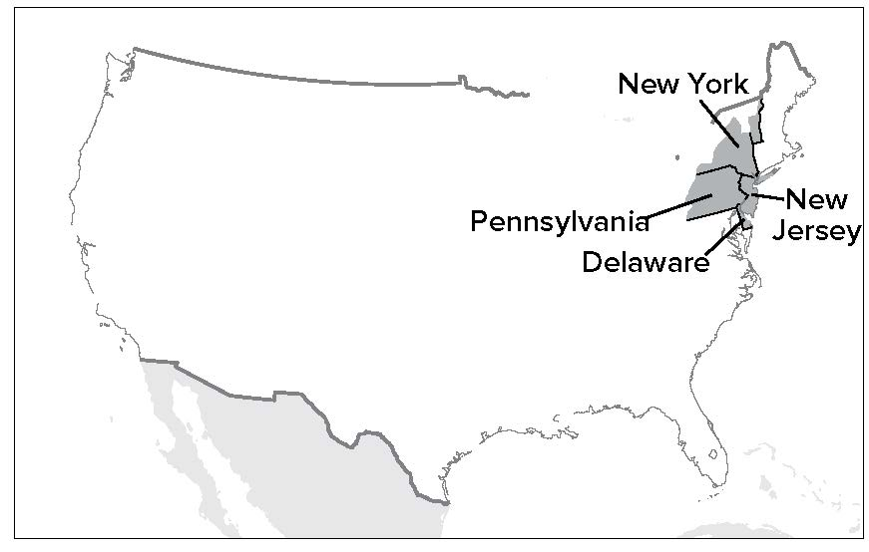

When did it happen?
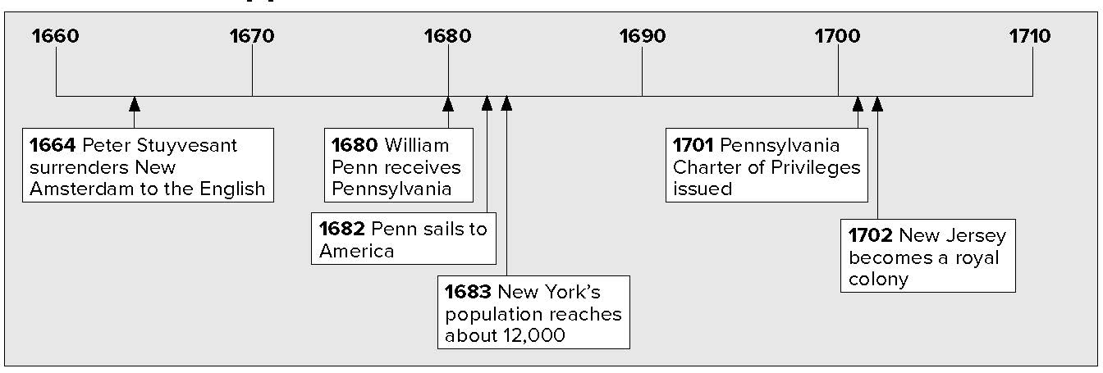

Lesson 3 The Middle Colonies, Continued

New York and New Jersey

Analyzing
1. What was the purpose of the patroon system?
Naming
2. What was the major settlement in New Netherland?
Identifying
3. By what name was New York City once known?
The Middle Colonies were the colonies in the middle of the east coast of North America. Some of these colonies were at first controlled by the European country called the Netherlands. This colony was called New Netherland. People from the Netherlands are called “Dutch.” New Netherland was under Dutch control.
The Dutch wanted more people to move to their colony of New Netherland. To get people to move there, they gave away land. The land giveaway worked like this: If someone could bring at least 50 new settlers to New Netherland, the Dutch would give that person a lot of free land. Not only that, but that person would get to rule the land and the settlers like a king. The landowners who got land this way were called patroons.

patroon landowner in the Dutch colonies who ruled over large areas of land

The most important settlement in New Netherland was New Amsterdam. It was located at the mouth of the Hudson River. The Hudson River was a major route inland. This made New Amsterdam a center of shipping to and from the Americas. It became a major port.
New Netherland and New Amsterdam were very successful.
The Dutch were very happy, but the English were not. They wanted to take over New Netherland so they could have this valuable colony for themselves. In 1664, the English sent warships to attack New Amsterdam. The Dutch governor, Peter Stuyvesant, surrendered without a fight.
England’s king gave the newly captured colony to his brother, the Duke of York. The duke changed the name of the colony from New Netherland to New York. New Amsterdam became New York City.

Dutch Control | England Takes Over | English Control
New Netherland | becomes | New York
New Amsterdam | becomes | New York City

Lesson 3 The Middle Colonies, Continued

New York continued to grow and prosper under English rule. When England took over in 1664, the colony was home to about 8,000 people. This included 300 enslaved Africans. By 1683, its population had grown to about 12,000. The residents included many Dutch, Germans, Swedes, and Native Americans. New York was also home to the first Jews to settle in North America.

Defining
4. What is another word for owner?
Reading
Check
5. Why did no major city develop in New Jersey?
Mark the Text
6. Underline the definition of pacifist. What religious group practiced pacifism?
7. Underline the last
sentence in the last paragraph on this page. What caused this result?
Before long, the Duke of York decided to divide his colony. He gave part of the land to two other nobles. This land became the colony of New Jersey. The two proprietors, or owners, named their colony after an island off the coast of England called Jersey.
Unlike New York, New Jersey had no natural harbors that could become a good port. So New Jersey did not develop a major city. However, like New York, people of many different racial, religious, and national backgrounds lived in New Jersey. To attract settlers, the proprietors offered large amounts of land. They also promised settlers freedom of religion, trial by jury, and a representative assembly.

Pennsylvania and Delaware
The colony of Pennsylvania was founded by Quakers. The Quakers were a Protestant religious group who had been mistreated in England. They believed that everyone was equal. They were also pacifists. Pacifists are people who refuse to use force or fight in wars. Welsh, Irish, Dutch, and German settlers also came to Pennsylvania.
The owner of the colony was named William Penn. (In fact, the name Pennsylvania means “Penn’s Woods.”) Penn founded his colony to put his Quaker ideas into practice.
He designed the colony’s main city of Philadelphia. The name means “city of brotherly love.” Penn came to America in 1682 to supervise the building of the city. Philadelphia quickly became the most popular port in the colonies.
What really makes Pennsylvania stand out, however, is the way Penn treated Native Americans. He believed that the land belonged to the Native Americans. Instead of just taking their land, he paid them for it. As a result, Pennsylvania had better relations with Native Americans than many other colonies.

Lesson 3 The Middle Colonies, Continued

Penn wrote Pennsylvania’s constitution and he took an active role in governing his colony. In 1701, Penn issued the Charter of Privileges. This document gave the colonists the right to elect representatives to a legislature, or lawmaking body. The Charter of Privileges was important because it was another step in setting up democracy in America.

Defining
8. What does a legislature do?
Reading
Check
9. What was William Penn’s main reason for founding Pennsylvania?
10. Use a one-tab
Foldable and place it along the dotted line to cover Check for Understanding. Write Middle Colonies in the center of the Foldable tab. Create a memory map by drawing arrows around the title and writing five or more short phrases that you remember about each of the Middle Colonies and the people that lived there. Use the reverse side to list additional information you recall.
When the colonists got the right to elect people to make their laws, some colonists in southern Pennsylvania wanted to have their own legislature. Many of these colonists were from Sweden. Sweden had started a colony there years before the Dutch and then the English took over the region. Penn let these colonists have their own legislature. Eventually this region became a separate colony called Delaware.

Glue Foldable here

Check for Understanding
Name two colonies that were formed from parts of other colonies and the colony from which each was formed.

Name two groups of people, besides the English, who lived in the Middle Colonies.

