Lesson 4 The Southern Colonies

ESSENTIAL QUESTION
How does geography influence the way people live?

GUIDING QUESTIONS
- What problems faced Maryland and Virginia?
- What factors contributed to the growth of the Carolinas?
Terms to Know
indentured servant person who agrees to work without pay for a certain period of time in exchange for passage to America
constitution written plan of government; a set of fundamental laws to support a government debtor person who owes money to another

Where in the world?
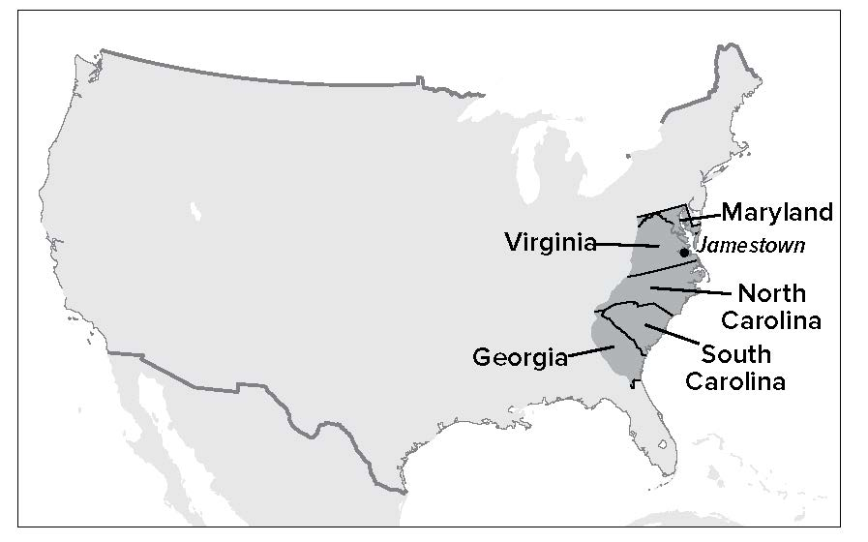

When did it happen?
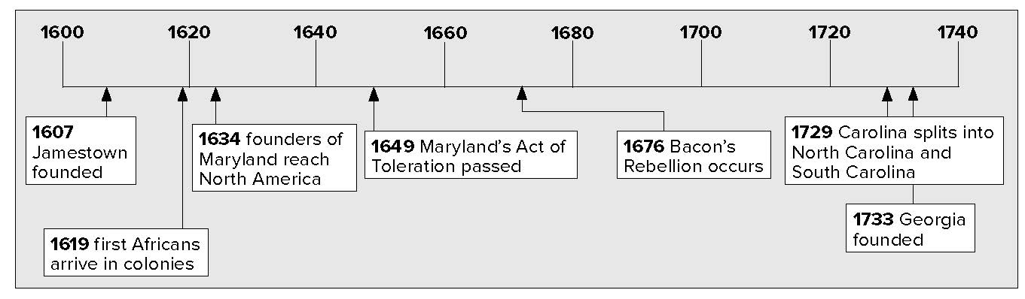

Lesson 4 The Southern Colonies, Continued

Virginia and Maryland

Analyzing
1. Why might a person agree to become an indentured servant and work for no pay?
Contrasting
2. How was an indentured servant different from an enslaved person?
Explaining
3. Why was Maryland founded?
Mark the Text
4. Underline the name of the law that granted religious freedom in Maryland.
Jamestown was settled in 1607. Over the years, it grew into a larger colony: the Virginia Colony. The Virginia colonists made their living by growing tobacco. It took a lot of workers to plant, take care of, and harvest this crop. Landowners forced enslaved Africans to do much of this work. The first Africans arrived in Virginia in 1619.
Not all workers were slaves. Many were indentured servants. These were people who agreed to work for a certain number of years for no pay. In exchange, their employers paid for their voyage to the colony.
In 1634, a new colony, called Maryland, began north of Virginia. Maryland was the dream of Sir George Calvert, Lord Baltimore. He wanted to found a colony where Catholics could practice their religion freely. At this time, Catholics in England were persecuted. Calvert’s son, Cecilius, worked to start the colony.
Cecilius offered free land to settlers who would come to Maryland. Upper class Englishmen were given large amounts of land. Average colonists were given less land. As in Virginia, wealthy landowners used enslaved Africans and indentured servants to do the work.
Before long, there were more Protestants than Catholics living in Maryland. To protect the Catholics’ religious freedom, the colony passed the Act of Toleration in 1649. However, the law did not end tension between the colony’s Protestants and Catholics. Eventually Maryland named one Protestant church as the official church of Maryland.
Other tensions arose over Maryland’s border with its northern neighbor, Pennsylvania. For many years, the two colonies argued over the exact location of the boundary between them. They finally agreed to settle the dispute once and for all. They hired Charles Mason and Jeremiah Dixon to map the border. This boundary became known as the Mason-Dixon line.
Virginia also experienced troubles during this time. James Berkeley, the governor of Virginia, promised Native Americans that settlers would not go farther west into their lands. Nathaniel Bacon was a farmer in western Virginia. He did not like the promise Governor Berkeley had made. In fact, many people in

Lesson 4 The Southern Colonies, Continued

Explaining
5. Why was Bacon’s Rebellion important?
Reading
Check
6. Why did Nathaniel

colonial government?
7. What is a constitution?
Listing
8. List three products that were important in North Carolina.

Explaining
5. Why was Bacon’s Rebellion important?
Reading
Check
6. Why did Nathaniel

colonial government?
7. What is a constitution?
Listing
8. List three products that were important in North Carolina.

Explaining
5. Why was Bacon’s Rebellion important?
Reading
Check
6. Why did Nathaniel Bacon oppose the
colonial government?
Defining
7. What is a constitution?
Listing
8. List three products that were important in North Carolina.
western Virginia did not like it. They wanted to be able to move farther west. They felt that the government of the colony was controlled by people from eastern Virginia who did not care about the problems of western Virginia.

Explaining
5. Why was Bacon’s Rebellion important?
Reading
Check
6. Why did Nathaniel

colonial government?
7. What is a constitution?
Listing
8. List three products that were important in North Carolina.
In 1676, Bacon led attacks on Native American villages. His army even marched to Jamestown and drove out Berkeley. They burned Jamestown down. Bacon was about to take over the colony when he died. Today, we remember this event as Bacon’s Rebellion. Bacon’s Rebellion was important in history because it showed that people wanted a government that would listen to their demands.

Bacon’s Rebellion
Cause
- unhappy with promise not to move into Native Americans’ land
- felt the government was controlled by people in the east
Effect
- showed that government must listen to the demands of the people

The Carolinas and Georgia
In 1663, King Charles II created a new colony. It was called Carolina, which is Latin for “Charles’s Land.” The new colony needed a constitution. A constitution is a written plan of government. An English political thinker named John Locke wrote the constitution for Carolina.
Farmers from Virginia settled in the northern part of Carolina. They grew tobacco and sold timber and tar. There was no good harbor in northern Carolina, so the farmers used Virginia’s ports. However, southern Carolina did have a good port at Charles Town (later Charleston).
Other crops were more important in southern Carolina. One of these was indigo. Indigo is a blue flowering plant. It was used to dye cloth. The other important crop was rice. Growing rice requires much labor, so the demand for slave labor increased.

Lesson 4 The Southern Colonies, Continued

In 1729, Carolina split into two separate colonies: North Carolina and South Carolina.

Mark the Text
- Underline the definition of debtors.

Reading Check
- Why was Georgia founded?
11. Use a one-tab
Foldable and place it along the dotted line to cover Check for Understanding. Write the title Southern Colonies on the anchor tab. Label the top of the Foldable tab Problems in Maryland and Virginia. Recall and record the problems that Southern colonies
had to face.

Carolina

North Carolina

South Carolina

The colony of Georgia was founded in 1733. It was the last colony set up by the English in North America. The founder of Georgia was James Oglethorpe. Georgia was to be a place where poor people and debtors (DEH • tuhrs) could get a fresh start. Debtors are people who owe other people money. England also hoped Georgia would protect the colonies from Spain. Spain had a colony in Florida, and Georgia stood between Spain and the other English colonies.
Glue Foldable here

Check for Understanding
What two things caused Bacon’s Rebellion?

List two problems that Maryland faced.

