Lesson 1 No Taxation Without Representation

ESSENTIAL QUESTION
Why does conflict develop?

GUIDING QUESTIONS
- Why did the British government establish new policies?
- How did the American colonists react to British policies?
Terms to Know
revenue money raised from taxes or other sources writ of assistance legal paper that allows officers to enter a place to search for smuggled goods
resolution a group’s official expression of opinion
effigy a doll-like figure that is meant to stand for an unpopular individual
boycott protest by refusing to buy items
repeal cancel

Where in the world?
i

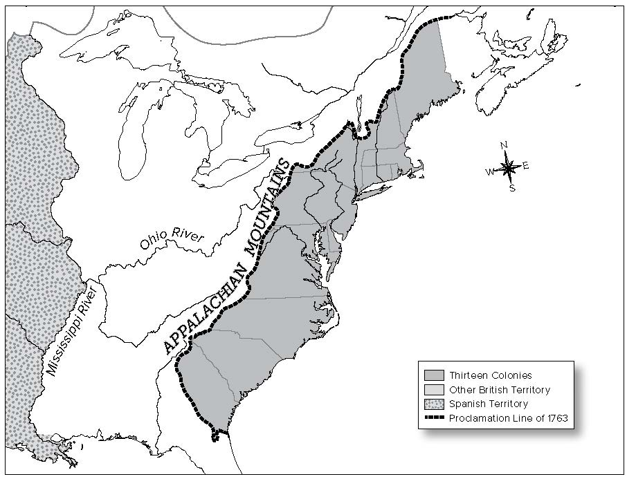

When did it happen?
i
e
i
i
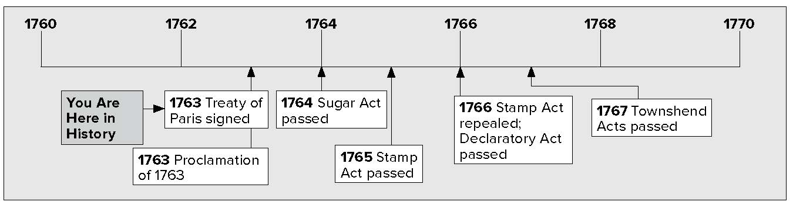

Lesson 1 No Taxation Without Representation, Continued

Listing
- State three reasons
that Britain issued
the Proclamation
of 1763.
Explaining
2. Why did Britain place new taxes on the colonists?
Making
Inferences
3. Why did Parliament approve writs of assistance?

Dealing With Great Britain
The French and Indian War was over. Now, the British controlled a lot of land in North America. They had to protect this land. To pay the costs of protecting the land, King George III made the Proclamation of 1763. A proclamation is an important announcement. These are the rules of the Proclamation of 1763.
- Colonists could not live on Native American lands that were west of the Appalachian Mountains. This would keep peace between settlers and Native Americans.
- This also made the colonists live close to the coast. It was easier for the British to control them that way. It also allowed Britain to control the trade of animal furs.
- King George sent 10,000 soldiers to the colonies. Their job was to make sure people obeyed the Proclamation of 1763. They also were there to keep peace with the Native Americans.
The British government needed revenue, or money, to give the soldiers food and supplies. Britain also had to pay back money it had borrowed to pay for the French and Indian War.
King George and Parliament thought the colonists should help to pay for these things. So, Britain made new taxes for the colonies. They made sure that colonists followed old tax laws, too.
Colonists did not want to pay taxes to Britain. One way to keep from paying taxes was to smuggle goods. Smuggling means bringing or taking goods in secret. When colonists smuggled goods, Britain did not get as much money from taxes.
In 1763, George Grenville was the prime minister of Britain.
He wanted to stop the smuggling. Parliament passed a new law. The law said if a smuggler was caught, judges chosen by King George would hear the case. Grenville knew that American courts usually did not find smugglers guilty.
There was another way to stop the smuggling. Parliament passed a law allowing writs of assistance. These were papers that gave officers the right to search for smuggled goods. They could search in shops, in warehouses, and in people’s homes.

Lesson 1 No Taxation Without Representation, Continued

Reading
Check
4. Why did Parliament
pass the Sugar Act?
Making
Generalizations
5. Why didn’t the
colonists like the laws Parliament passed?

In 1764, Parliament passed a law called the Sugar Act. This law lowered the tax on molasses, a kind of sweetener. The British government hoped that colonists would pay a lower tax instead of smuggling. The law also allowed officers to take smuggled goods without getting permission.
Colonists were angry about the Sugar Act. They knew that they were British citizens. They knew that British citizens had certain rights:
  - They had the right to a jury trial.
  - According to law, they were innocent until proven guilty.
  - They had the right to feel safe in their homes without soldiers coming in to search for smuggled goods.

New Taxes on the Colonies
In 1765 Parliament passed the Stamp Act. This law taxed printed items, such as newspapers. Colonists did not like the Stamp Act at all.
In Virginia, a representative named Patrick Henry did not like the law. He convinced the House of Burgesses to act against the law. They passed a resolution against the Stamp Act. A resolution is an official statement.
The resolution said that only the Virginia assembly had the power to tax Virginia citizens.
In Boston, Samuel Adams worked against the Stamp Act. He helped to start a protest group called the Sons of Liberty. The Sons of Liberty burned effigies (EH • fuh • jeez), or large, stuffed dolls. The dolls were made to look like tax collectors.
In October 1765, delegates from nine colonies met in New York. The meeting was called the Stamp Act Congress. The delegates wrote a resolution. They sent it to the British Parliament and to King George. Colonial businessmen decided to boycott, or refuse to buy, British goods. Many businessmen promised not to buy or use goods that came from Britain.
People followed the boycott. Not enough people were buying British goods. As a result, British merchants lost a lot of money. British merchants asked Parliament to repeal, or cancel, the Stamp Act.

Lesson 1 No Taxation Without Representation, Continued

In 1766, Parliament canceled the law. It passed another law instead. This law was the Declaratory Act. It said that Parliament had the right to tax the colonists.

Mark the
Text
- Circle the words that explain what the Daughters of Liberty encouraged people to do to protest the taxes.

Reading Check
- How did the Townshend Acts differ from the Stamp Act?
8. Use a three-tab
Foldable and place it along the dotted line to cover Check for Understanding. Write the title Taxes on the anchor tab. Label the tabs Sugar Act, Stamp Act, and Townshend Acts. Use both sides of the tabs to list facts you remember about taxes placed on the colonists. Use the Foldable to help answer Check for Understanding.
In 1767 Parliament passed the Townshend Acts. The Townshend Acts taxed goods that were imported, or brought into, the colonies. By now, any British taxes made colonists angry. Groups of women protested. They told colonists to make cloth at home and wear it. This way, they would not have to buy cloth from Britain. Some of these groups called themselves the Daughters of Liberty.

Glue Foldable here
Check for Understanding
List two laws that taxed colonists.
Name three ways that colonists protested the tax laws passed by Parliament.

