Lesson 2 Uniting the Colonists

ESSENTIAL QUESTION
Why does conflict develop?

GUIDING QUESTIONS
- How did the American colonists react to the Boston Massacre?
- How did the British government react to the actions of the colonists?
Terms to Know
rebellion open defiance of authority propaganda ideas or information spread to harm or help a cause
committee of correspondence an organization that spread political ideas and information through the colonies

When did it happen?
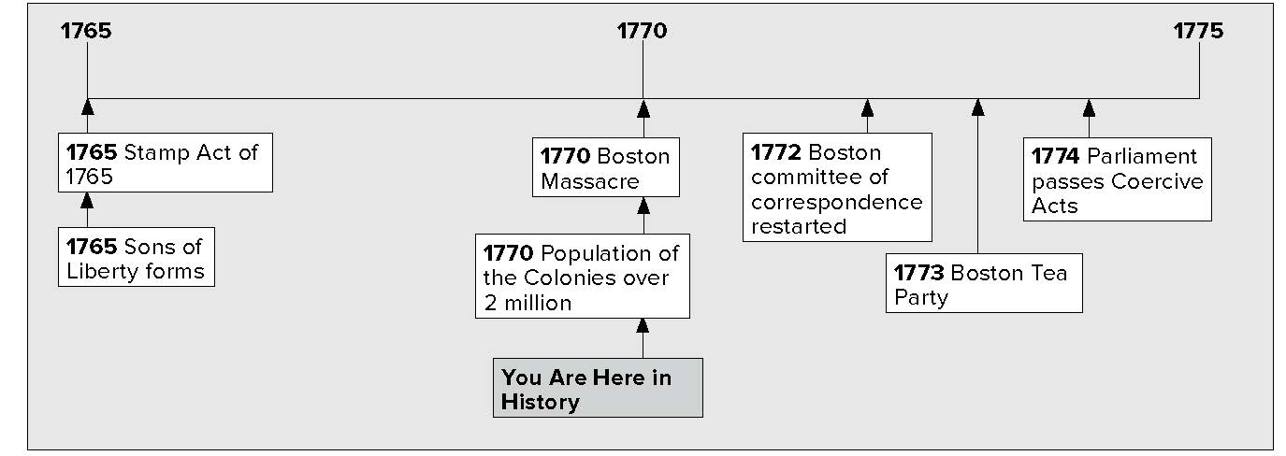

What do you know?
In the first column, answer the questions based on what you know before you study. After this lesson, complete the last column.

Now... |  | Later...
 | Who was Crispus Attucks?
 | How did the colonists use propaganda?

Lesson 2 Uniting the Colonists, Continued

Trouble in Massachusetts

Mark the Text
1. Locate and underline the definition of rebellion.
Defining
2. What is propaganda?
Explaining
3. Why did the people of Boston dislike the British soldiers?

Reading
Check
4. What changed after
the Boston Massacre?

Colonists kept on protesting. This made British officials nervous. In 1768 they sent a message to Britain. The message said the colonies were close to rebellion. Rebellion means to reject the rules and authority of Britain.
Parliament sent soldiers, called “redcoats,” to the city of Boston, Massachusetts. These redcoats set up camp in the center of Boston.
Now, the colonists decided the British had gone too far.
Besides, British soldiers were rude to the people of Boston. The soldiers were mostly poor people. Sometimes they stole from the colonists. Sometimes the soldiers got into fights with them.
On March 5, 1770, a fight broke out between a group of soldiers and citizens of Boston. Here is what happened.

A fight broke out.
British officers tried to calm people down.
Colonists threw sticks and stones at British soldiers.
The soldiers became afraid. They fired their guns into the crowd.
March 5, 1770–The “Boston Massacre”
Five colonists were killed.

One of the colonists was Crispus Attucks. He was a worker on the docks. He was part African and part Native American.
The colonists called the event the “Boston Massacre.” A massacre is when a large number of people are killed. Colonists used the killings as propaganda. Propaganda is using information to make people think or feel a certain way. Samuel Adams put up posters to make people angry at the British. The posters showed soldiers killing the citizens of Boston.
Many colonists called for stronger boycotts. Parliament repealed, or took away, most of the Townshend Acts, but they kept the tax on tea. As a result, colonists ended most of their boycotts. They still kept the boycott on tea.

Lesson 2 Uniting the Colonists, Continued

Understanding
Cause and Effect
5. Why did Parliament pass the Tea Act?
6. Why did Parliament
pass the Coercive Acts?

In 1772 Samuel Adams restarted a group called the committee of correspondence. The group wrote their complaints about Britain and the British. They sent these writings around to many places. More committees of correspondence started in other colonies. These groups brought protesters together and made them stronger against the British.

Understanding
Cause and Effect
5. Why did Parliament pass the Tea Act?
6. Why did Parliament
pass the Coercive Acts?

Crisis in Boston
There was a British company called the British East India Company. It was not doing well. The reason was that colonists were not importing their tea. They were nearly out of business.
Parliament passed a law to help save the company. The law was the Tea Act. The Tea Act gave the company almost total control of the tea market in the colonies. The Tea Act also took away some, but not all, of the taxes on tea. Colonists did not want to pay any taxes on tea. They also did not want Parliament telling them what tea to buy.
Colonists called for a new boycott. They decided to stop ships from the British East India Company from unloading their tea. The Daughters of Liberty put out a booklet. It said that rather than part with freedom, “We’ll part with our tea.”
Still, the British East India Company kept on shipping tea to the colonies. Colonists in New York and Philadelphia made the ships turn back.
In 1773, three tea ships arrived in Boston Harbor. The royal governor ordered the ships to be unloaded. On the night of December 16, 1773, the Sons of Liberty in Boston took action. They dressed up as Native Americans and boarded the ships. They threw 342 large boxes of tea overboard. This event became known as the “Boston Tea Party.” King George III heard about the Boston Tea Party. He saw that Britain was losing control of the colonies.
In 1774, Britain passed the Coercive (co • UHR • sihv) Acts. Coercive means “for the purpose of forcing someone.” These laws were passed to punish the colonies. One of the laws forced colonists to let British soldiers live among them.
Massachusetts was punished the hardest. There could be no more town meetings there. Boston Harbor was closed until colonists paid for the tea they had thrown overboard.

Lesson 2 Uniting the Colonists, Continued

With the harbor closed, no other food or supplies could get into Boston. The Coercive Acts united the colonists. They sent food and clothing to Boston.

Reading
Check
7. List the effects of the Coercive Acts on the citizens of Boston.
8. Use a one-tab
Foldable and place it along the dotted line to cover Check for Understanding. Write the title Memory Map on the anchor tab.
Write Colonists React in the middle of the Foldable tab and draw arrows from the title. Write terms you remember that explain the actions of the colonists. Define the terms on the back of the tab. Use the Foldable to help answer Check for Understanding.
Parliament then passed the Quebec Act. This law created a government for Canada. Canada’s border was the Ohio River, much further south than present-day Canada.
Colonists said all these laws violated their rights as English citizens. Colonists called these laws the Intolerable Acts. Intolerable means “unbearable.”
Glue Foldable here
Check for Understanding
What kinds of propaganda were used in reporting about the “Boston Massacre”?

How are the Boston Tea Party and the Intolerable Acts connected?

