Lesson 3 A Call to Arms

ESSENTIAL QUESTION
What motivates people to act?

GUIDING QUESTIONS
- What role did key individuals play in the movement toward independence?
- Why were the battles at Lexington and Concord important?
- What were the beliefs of the Loyalists and Patriots?
Terms to Know
minutemen people who could be ready to fight as soldiers with one minute’s notice
Loyalists American colonists who remained loyal to Britain and were against the war for independence
Patriots American colonists who wanted American independence

When did it happen?
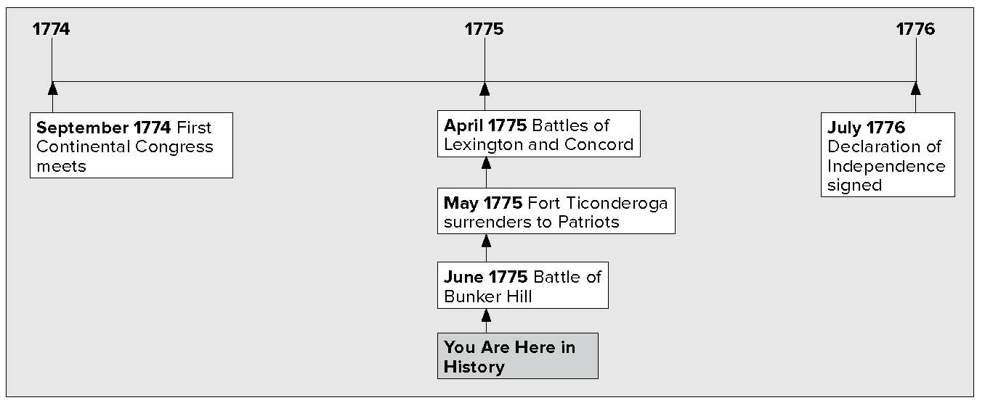

What do you know?
In the first column, answer the questions based on what you know before you study. After this lesson, complete the last column.

Now... |  | Later...
 | Who was Thomas Gage?
 | Where is Breed’s Hill? What happened there?

Lesson 3 A Call to Arms, Continued

A Meeting in Philadelphia

Listing
1. List three things
the Continental Congress did.
Reading
Check
2. What was the purpose
of the Continental Congress?
3. Place a two-tab
Foldable along the dotted line under the heading “Fighting Begins.” Write the title Fighting Begins on the anchor tab. Label the two tabs Lexington and Concord. On both sides of the tabs, list words and phrases to describe each encounter.
Fifty-five delegates met in Philadelphia. They came from every colony except Georgia. They met to discuss how the colonies could challenge British control. The meeting was called the Continental Congress. John Adams, Samuel Adams, and Patrick Henry were delegates. John Jay, Richard Henry Lee, and George Washington were also delegates.
The delegates to the Continental Congress:
- issued a statement asking Parliament to repeal several laws that violated colonists’ rights.
- voted to boycott trade with Britain. This included all goods coming into and going out of the colonies.
- decided to approve the Suffolk Resolves. This called for the colonists to arm themselves against the British.
In Massachusetts, the militia began to train and gather weapons. A colonial militia was a group of citizens who served as part-time soldiers to help protect the colony. Some militias claimed they could be ready to fight in just one minute. These groups were known as minutemen.

Fighting Begins

The British also got ready to fight. King George III saw that the New England colonies were rebelling. By April 1775, thousands of British soldiers were in and around Boston.
King George gave an order to British general Thomas
Gage. He told General Gage to get rid of the militia’s weapons. He ordered General Gage to arrest the militia’s leaders. General Gage heard that the militia kept its weapons in a town near Boston. The name of the town was Concord. On April 18, 1775, Gage sent 700 soldiers to Concord to destroy the weapons.
Colonists in Boston saw the soldiers march out of town. Paul Revere and William Dawes, members of the Sons of Liberty, rode to Lexington. Lexington was a town near Concord. They warned colonists that the British were coming.
About 70 minutemen met the British at Lexington. Someone fired a shot, and then both sides began firing. Eight minutemen

Lesson 3 A Call to Arms, Continued

were killed. The British moved on to Concord. They found that most of the militia’s gunpowder had been taken away. They destroyed all the supplies that were left. Then the minutemen fought with the British soldiers. They forced the soldiers to turn back.

Sequencing
4. Number the events in the order in which they happened.
Revere and Dawes warn that the British are coming.
Battle of Concord
British soldiers ordered to destroy the Massachusetts militia’s weapons.
Battle of Lexington
Reading
Check
5. Why did British troops
march to Concord?
Reading
Check
6. What did the British learn from the Battle of Bunker Hill?
Word quickly spread that the British were on the move. Along the road from Concord to Boston, colonists hid behind trees and fences. As British troops marched back to Boston, the colonists fired. By the time the British reached Boston, 73 of their soldiers had been killed. At least 174 soldiers had been wounded.

More Military Action
After what happened at Lexington and Concord, many colonists joined militias. Benedict Arnold was an officer in the Connecticut militia. He got 400 men to join his militia.
Benedict Arnold and his army set out to capture Fort Ticonderoga on Lake Champlain. He joined forces with Ethan Allen and the Vermont militia. The Vermont militia were called the Green Mountain Boys.
Together, the two groups attacked the British soldiers. It was a surprise attack. The British surrendered Fort Ticonderoga on May 10, 1775.
Later, Benedict Arnold turned against the Patriot cause. He sold military information to the British. When he was found out, he fled to New York City. New York City was controlled by the British. Arnold commanded British soldiers. He led attacks against the Americans.
More American soldiers began joining colonial militias. Before long, there were about 20,000 militiamen around Boston. On June 16, 1775, Colonel William Prescott had his militia set themselves up on Bunker Hill and Breed’s Hill. These places were across the harbor from Boston. The British decided to force the colonists from the hills.
The next day, British soldiers charged up Breed’s Hill. (However, this battle is called the Battle of Bunker Hill.) The Americans were running out of ammunition, and Prescott is said to have shouted, “Don’t fire until you see the whites of their eyes.”
The militia fired. They stopped the British attack. Twice more the British attacked, but were stopped. Finally, the Americans ran out of gunpowder. They had to retreat. The British won this battle, but more than 1,000 of their soldiers were killed or wounded. The British were learning that it was going to be a hard fight against the Americans.

Lesson 3 A Call to Arms, Continued

7. Place a three-tab Foldable along the dotted line to cover Check for
Understanding. Write Loyalist or Patriot on the anchor tab. Label the tabs Paul Revere, Both, and Benedict Arnold. On the reverse sides, write words and phrases that you remember about each to compare and contrast the men. Use the Foldable to help answer Check for Understanding.

News about the battles spread. Colonists had to decide whether to join the rebels or stay loyal to Britain. Colonists on the British side were called Loyalists. They did not think that unfair taxes and unfair laws were good reasons to fight. Many believed the British would win and did not want to be on the losing side. Colonists who supported the war for independence were called Patriots. They felt they could no longer live under British rule. The American Revolution was not just a war between the British and the Americans. It was also a war between American Patriots and American Loyalists.

Check for Understanding
Identify each battle.
The first shot of the American Revolution is fired.

The Green Mountain Boys catch the British by surprise.

The British attack uphill.

What is the difference between a Loyalist and a Patriot?

