Lesson 4 Declaring Independence

ESSENTIAL QUESTION
What motivates people to act?

GUIDING QUESTIONS
- How did individuals and events impact efforts for independence?
- Why did the American colonies declare independence?
Terms to Know
petition a formal request
preamble the introduction to a formal document that often tells why the document was written

When did it happen?

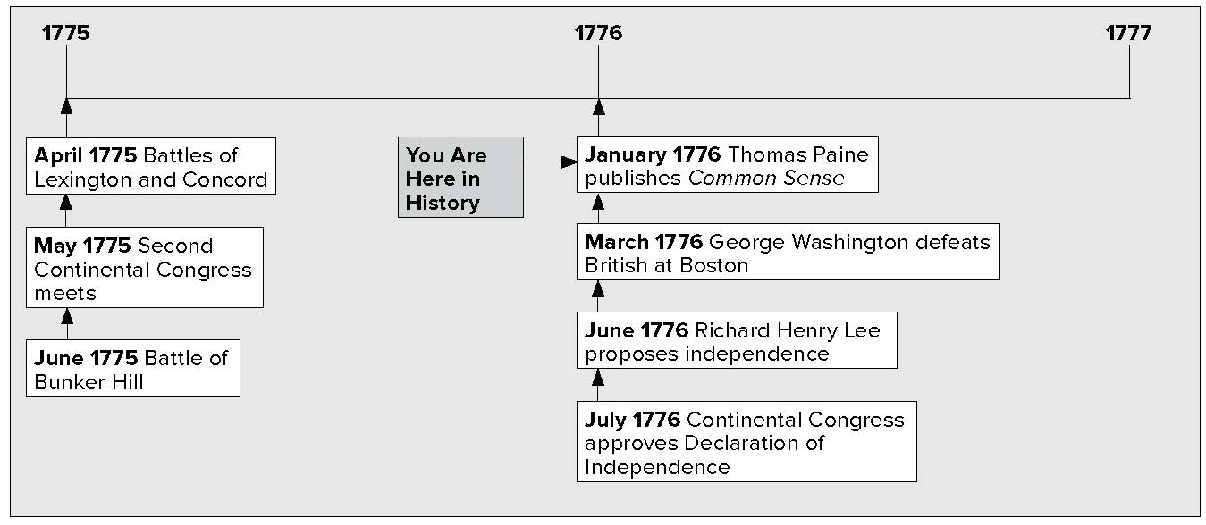

What do you know?
In the first column, answer the questions based on what you know before you study. After this lesson, complete the last column.

Now... |  | Later...
 | What was the Second Continental Congress?
 | What was the booklet, Common Sense?
 | What did Jefferson have to do with the Declaration of Independence?

Lesson 4 Declaring Independence, Continued

Listing
- Name five delegates
to the Second
Continental Congress.
Making
Inferences
2. Based on what the Continental Congress
did, write a definition
for govern.
Reading
Check
3. What was the
purpose of the Olive Branch Petition?

The Second Continental Congress
On May 10, 1775, the Second Continental Congress met. The delegates included some of the greatest leaders in America. Among them were John and Samuel Adams, Patrick Henry, Richard Henry Lee, and George Washington. Several new delegates came as well.
Benjamin Franklin of Pennsylvania was well respected. He had been a leader in the Pennsylvania legislature. In 1765 he had gone to London and worked to have the Stamp Act repealed.
John Hancock of Massachusetts was a wealthy merchant. He used his money to run many Patriot groups. The Sons of Liberty was one of the many Patriot groups. The delegates chose John Hancock to be president of the Second Continental Congress.
Thomas Jefferson of Virginia was only 32 years old. He was in the Virginia legislature. He was already famous for his thoughts and his writing. He was a delegate to the Second Continental Congress.
The Second Continental Congress began to govern the colonies.
- It allowed money to be printed.
- It set up a post office.
- It set up committees to handle relations with Native Americans and with other countries.
- It created the Continental Army. This would allow colonists to fight the British in a more organized way.
- It chose George Washington to command the army.
The Congress gave Britain one more chance to avoid war. It sent a petition, a formal request, to King George III. The request was called the Olive Branch Petition. It said that the colonists wanted peace. It asked King George to protect their rights. King George would not accept the petition. Instead, he got ready for war.
The Americans found out that British soldiers were planning to attack New York from Canada. The Americans decided to attack first. They sent soldiers northward from Fort Ticonderoga and captured Montreal.
In July 1775, George Washington arrived in Boston. He found the militia was not well organized, so he trained them. He brought many cannons from far away.

Lesson 4 Declaring Independence, Continued

Mark the Text
4. Underline the name
of the booklet and
the author who encouraged independence
from Britain.
Specifying
5. Who was chosen to write the Declaration of Independence?
Reading
Check
6. According to John Locke, what is the purpose of government?

In March 1776, Washington decided the soldiers were ready to fight. He moved the soldiers and the cannons to the hills overlooking Boston while the British soldiers slept.
The British were surprised. British General William Howe commanded his soldiers to sail away from Boston. On March 17, Washington led his soldiers into the city.
Colonist Thomas Paine wrote a booklet called Common Sense. It explained why complete independence from Britain would be a good thing. Paine’s words had a great effect on colonists and how they felt.

Declaring Independence
The delegates at the Second Continental Congress argued back and forth. Some wanted the colonies to declare independence. Others did not. In June 1776, Richard Henry Lee of Virginia came up with a resolution. The resolution stated that the United Colonies should be free and independent states, a new nation.
Congress chose a committee to write a Declaration of Independence. John Adams, Benjamin Franklin, Thomas Jefferson, Robert Livingston, and Roger Sherman were on the committee. Adams asked Jefferson to write it.
Jefferson was inspired by the ideas of an English philosopher named John Locke.

John Locke’s Ideas
People have the right to life, liberty and property.
- People are born with these rights.
- People form a government to protect their rights.
- If the government does not protect their rights, people can get rid of the government.

The delegates discussed Jefferson’s Declaration of Independence. They made some changes. Then they approved it on July 4, 1776. John Hancock signed first. He said he wrote his name large enough for King George to read without his glasses. Eventually 56 delegates signed the document announcing the birth of the United States.
Copies were made and sent to the states. George Washington had the Declaration read to his soldiers.

Lesson 4 Declaring Independence, Continued

7. Use a one-tab Foldable and place it along the dotted line to cover Check for Understanding. Write Declaration of Independence in the middle of the Foldable tab and draw arrows from the title to words and short phrases that you recall about the Declaration of Independence. Use the Foldable to help answer Check for Understanding.

The Declaration of Independence has four main parts.
- First is a preamble, or introduction. It says that people who wish to form a new country should explain their reasons.
- and 3. The next two parts list the rights that the colonists believed they should have and their complaints against Britain.
4. The last section announces that they have formed a new nation.
John Adams thought July 2, 1776, should be the holiday that celebrated independence. This was the day that the Congress voted for independence. Instead, July 4 is celebrated today as Independence Day. This is the day the Declaration was approved.

Check for Understanding
Explain the connection between John Locke, Thomas
Jefferson, and the Declaration of Independence.

What was the most important result of the Declaration of Independence?

