Monday—Define the following:

- astrolabe—

- peninsulares—
Tuesday
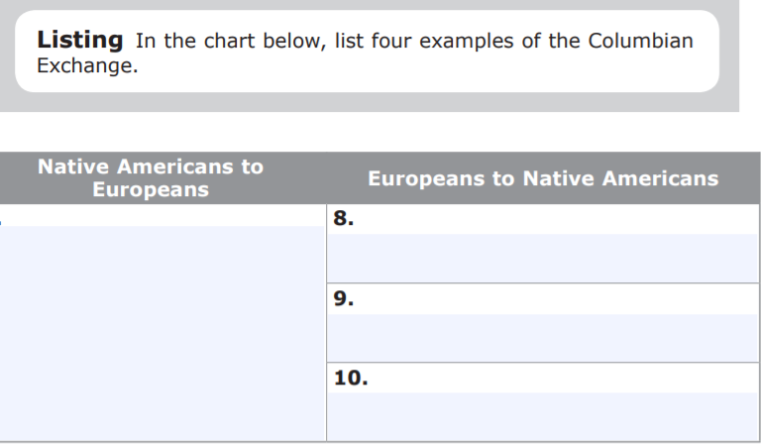

Wednesday

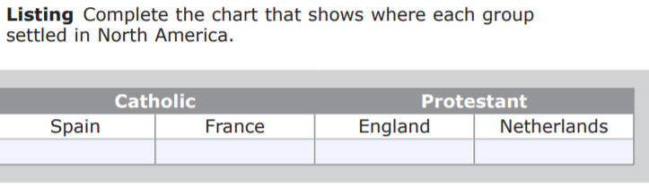
Thursday—Discuss what these had to do with advancing European exploration.

- shipbuilding—

- astrolabe & quadrant—

- maps—

Friday
