Monday and Tuesday—Reference Chapter 3, Lesson 1 and complete the chart below.

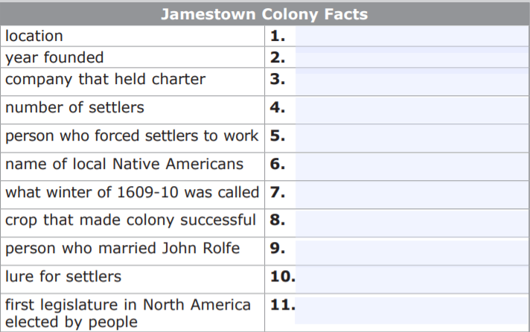
Wednesday-Friday