Nearpod Live Activity Sheet #3
Directions: Match each document letter (A, B, C, D, E, F, G, H) with the Judeo-Christian principle that had an influence on America’s constitutional republic.
- Which two documents represent Justice? Explain your answer below.
- “We hold these truths to be self-evident, that all men are created equal, that they are endowed by their Creator with certain unalienable Rights, that among these are Life, Liberty and the pursuit of Happiness.” -Declaration of Independence

B. “The history of free men is never really written by chance but by choice; their choice!” –Dwight D. Eisenhower

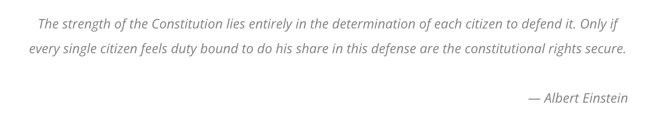
C.

D.

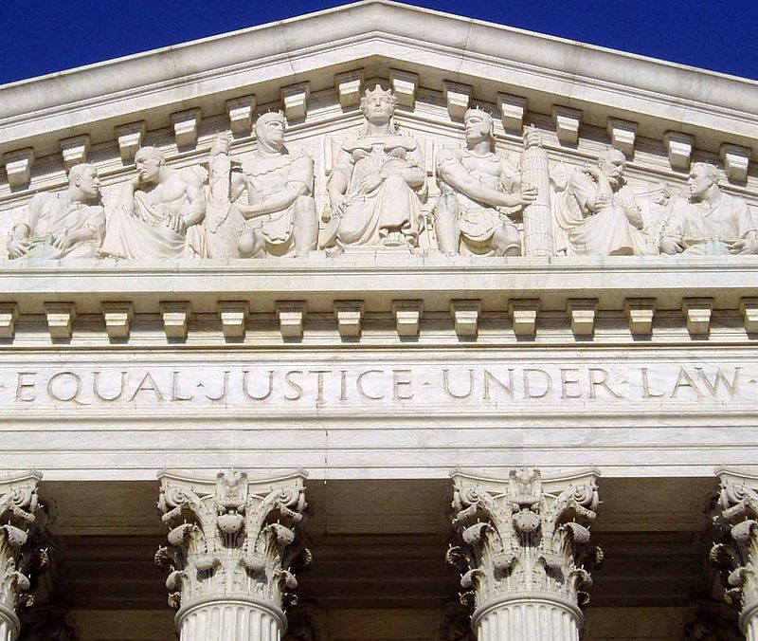
2. Which two documents represent Individual Worth? Explain your answer below.

E.
The 6th amendment of the U.S constitution protects the rights of an individual being accused of a crime.

3. Which two documents represent Personal Responsibility? Justify your answer below.

F.
Before he enter on the Execution of his Office, he shall take the following Oath or Affirmation:--"I do solemnly swear (or affirm) that I will faithfully execute the Office of President of the United States, and will to the best of my Ability, preserve, protect and defend the Constitution of the United States." -Article II section 1

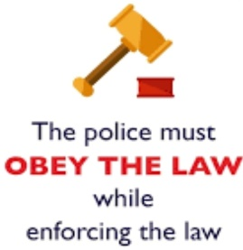
4. Which two documents represent Rule of Law? Justify your answer below.
H.
G.
“We the People of the United States, in Order to form a more perfect Union… promote the general Welfare…” -Preamble of the U.S Constitution

