Lesson 2 Early Challenges

ESSENTIAL QUESTION
Why does conflict develop?

GUIDING QUESTIONS
- What challenges on the frontier did the new government face?
- Why did Washington want to remain neutral in foreign conflicts?

Term to Know
impressment seizing people against their will and forcing them to serve in the military or other public service

Where in the world?
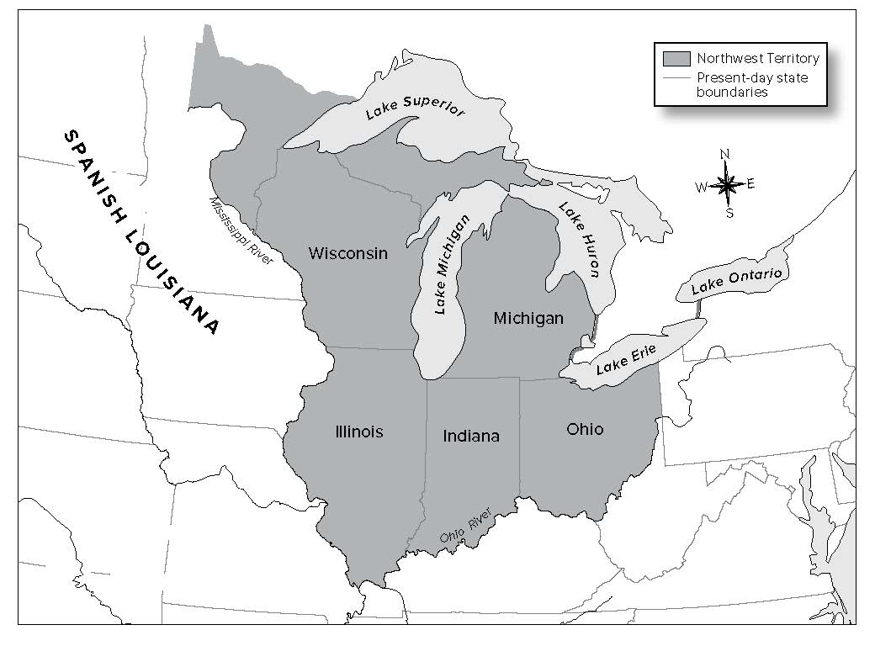

When did it happen?
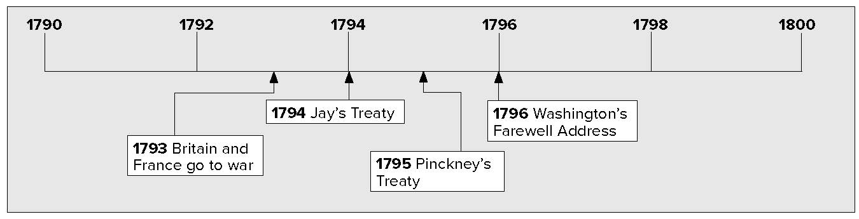

Lesson 2 Early Challenges, Continued

Trouble in the New Nation
The new government faced many problems. In western Pennsylvania farmers opposed a tax on whiskey. In 1794, an armed mob attacked tax collectors. They burned down buildings. This armed protest was called the Whiskey Rebellion. It worried government leaders. President Washington and his advisers decided to crush the protest using the army. This sent a message to people: the government would use force when necessary to maintain, or keep, order.
In the Northwest Territory, Native Americans tried to stop American settlers from moving west. Washington signed treaties with the Native Americans. He did not want the Native Americans to be influenced by Great Britain or Spain. American settlers ignored the treaties. They moved into lands promised to the Native Americans. Fighting broke out. Washington sent General Arthur St. Clair to restore order, but St. Clair was defeated in 1791.
Britain and France wanted to bring the United States into their own conflicts. The British were afraid that the United States would help France. They asked Native Americans to attack American settlements west of the Appalachian Mountains. Washington sent an army under General Anthony Wayne. The army defeated the Native Americans at the Battle of Fallen Timbers in 1794. The Native Americans signed the Treaty of Greenville. They agreed to give up most of the land in what is now Ohio.

CONFLICTS
Where? | Who? | What happened?
Western Pennsylvania | Farmers and others | Whiskey Rebellion crushed by Washington
Northwest Territory | Gen. Arthur St. Clair | U.S. troops defeated by Native Americans
West of Appalachian mountains | British | Asked Native Americans to attack American settlers
Ohio | Gen. Anthony Wayne | Defeated Native Americans at the Battle of Fallen Timbers; Native Americans signed Treaty of Greenville

Identifying

- What three European countries were involved in American affairs?

Evaluating

- Underline the sentence that describes the message the government sent by crushing the Whiskey Rebellion.
Do you think the message was effective?

Reading Check

- How did settlers moving west react to the treaties signed by Native Americans?

Lesson 2 Early Challenges, Continued

Vocabulary

- What was
impressment?

Determining Cause and Effect

- What was the result of Pinckney’sTreaty?

Reading Check

- What did the Proclamation of Neutrality do?

Problems with Europe
Britain and France went to war in 1793. Some Americans sided with France and others supported Britain. Washington hoped that the United States could stay neutral. Neutral means not taking sides in a conflict.

The French tried to get American volunteers to attack British ships. In response, President Washington issued a Proclamation of Neutrality. It declared that American citizens could not fight in the war. It also stopped French and British warships from using American ports. The British captured American ships that traded with the French. They forced the American crews into the British navy. This practice was called impressment. It angered the Americans.
Washington sent John Jay to work out a peaceful solution with Britain. Jay proposed a treaty. In Jay’s Treaty, the British would agree to leave American soil. But the treaty did not deal with the problems of impressment. It also did not deal with the British interfering with American trade. Jay’s Treaty was unpopular, but the Senate approved it.
Spanish leaders feared that the United States and Great Britain would work together against them in North America. Thomas Pinckney went to Spain to settle the differences between the United States and Spain. In 1795 he proposed a treaty that said Americans could travel on the Mississippi River. Pinckney’s Treaty also gave Americans the right to trade at New Orleans.

Jay’s Treaty
  - British agreed to leave American soil
  - Did not deal with impressment
  - Did not deal with British interfering with American trade
  - Unpopular

Pinckney’s Treaty
- Between Spain and the U.S.
- Gave Americans right to travel the Mississippi River
- Gave Americans right to trade at New Orleans

Washington decided to retire and not run for a third term as president. In his last speech, he warned the country not to get involved in foreign problems. He also warned against creating political parties.

Lesson 2 Early Challenges, Continued

Glue Foldable here

Check for Understanding

List four challenges faced by the new government within the United States.

4 _____________________________________________

List the two treaties that the United States signed with
foreign countries to resolve conflicts.

7. Place a two-tab Foldable along the dotted line to cover Check for
Understanding. Write the title Challenges on the anchor tab. Label the tabs—Conflicts in
U.S. and Foreign Conflicts. Use both sides of the tabs to record what you recall about each and write facts about who was involved and what happened. Use the Foldable to help answer Check for Understanding.

