Lesson 3 The First Political Parties

ESSENTIAL QUESTION
How do governments change?

GUIDING QUESTIONS
- How did different opinions lead to the first political parties?
- What important events occurred during the presidency of John Adams?
Terms to Know
partisan firmly favoring one party or faction
caucus a meeting of members of a political party
to choose candidates for upcoming elections
alien a person living in a country who is not a citizen of that country
sedition activities aimed at weakening the established government by inciting resistance or rebellion to authority
nullify to legally overturn
states’ rights the idea that states should have
all powers that the Constitution does not give to
the federal government or forbid to the states

When did it happen?
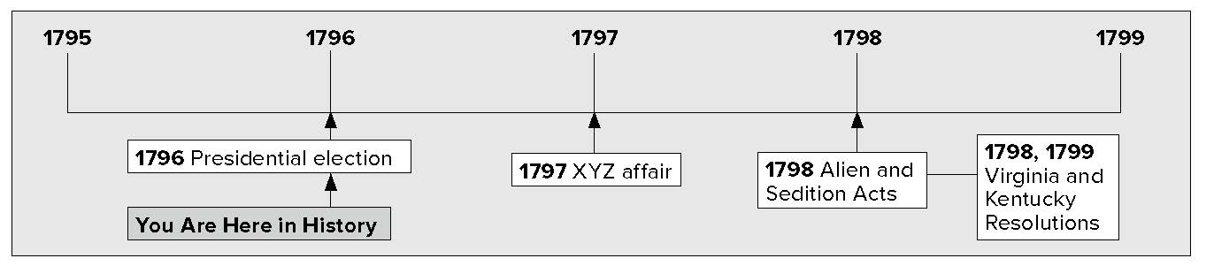

What do you know?
In the first column, answer the questions based on what you know before you study. After this lesson, complete the last column.

Now... |  | Later...
 | How did people feel about political parties when Washington was president?
 | What were the first two political parties in America?
 | Did President John Adams and Vice President Thomas Jefferson have similar views about government?
 | Why were Americans suspicious of aliens during this period?
 | Why did some states believe they had the power to overturn federal laws?

Lesson 3 The First Political Parties, Continued

Opposing Parties

Defending
1. Underline the sentences that describe two opinions about political parties. Which opinion do you agree with? Why?
Identifying
2. Name the two political parties and the leader of each.
Reading
Check
3. What was different about the election of 1796?
President Washington warned against political parties. He was afraid that political parties would divide the nation. Others thought that it was natural for people to disagree about issues. By 1796, Americans were beginning to split into two different groups.
In Washington’s cabinet, Alexander Hamilton and Thomas Jefferson often disagreed. They disagreed about economic policy and foreign relations. They disagreed about how much power the federal government should have. They also disagreed on the rules of the Constitution. Even Washington was partisan— favoring one side of an issue. Washington usually supported Hamilton’s positions. These disagreements caused both Hamilton and Jefferson to resign from, or leave, the cabinet. The two political parties that formed were called Federalists and Republicans.

Federalists Republicans
Headed by Alexander Hamilton | Headed by Thomas Jefferson
Supported government by representatives | Feared strong central government controlled by only a few people
Believed government had broad powers implied by the Constitution | Believed government only had powers specifically stated in the Constitution

In 1796, there was a presidential election. Before the election, the two parties held meetings called caucuses. At the caucuses, members of Congress and other leaders chose their parties’ candidates for office.
The Federalists chose John Adams for president. The Republicans chose Thomas Jefferson. This was the first time candidates identified themselves as members of political parties.
Adams received 71 electoral votes to win the election.
Jefferson finished second with 68 votes. Under the Constitution at that time, the person with the second-highest number of electoral votes became vice president. Jefferson became the new vice president. The new government in 1797 had a Federalist president and a Republican vice president.

Lesson 3 The First Political Parties, Continued

John Adams as President

- Place a four-tab
Foldable along the dotted line to cover the text beneath the title John Adams as President. Write the title John Adams on the anchor tab. Label the four tabs—Who, What, When, and Where. On both sides of the tabs, write what you recall about President John Adams and how he handled the capture of American ships by the French.

Identifying
- Who were the people that President Adams referred to as X, Y, and Z?
Reading
Check
6. What was important about the Virginia and Kentucky Resolutions of 1798 and 1799?
Glue Foldable here
When Adams became president, France and the United States could still not agree. The French thought that Jay’s Treaty allowed Americans to help the British. The French captured American ships that carried goods to Britain.
In 1797, Adams sent a team to Paris to try to end the disagreement. The French officials refused to meet with the Americans. Instead, they sent three agents. They demanded a bribe from America and a loan for France. Adams was angry at the French actions. He called the French agents “X, Y, and Z.” Adams urged Congress to prepare for war. This was called the XYZ affair.

XYZ Affair
•

•
•
French captured American ships carrying goods to Britain
Adams sent a team to France
Three French agents, known as X, Y, and Z, tried to get a bribe and a loan from Americans

People were angry with France. Americans became more suspicious of aliens. Aliens are immigrants living in a country who are not citizens of that country. Federalists passed laws to protect the nation’s security. In 1798, they passed a group of laws known as the Alien and Sedition Acts. Sedition means activities that weaken the government. The Alien Act allowed the president to put aliens in prison. He could also send them out of the country if he thought they were dangerous. Later, France and the United States signed a treaty which stopped French attacks on American ships.
The Virginia and Kentucky Resolutions were passed in 1798 and 1799. They claimed that the Alien and Sedition Acts did not follow the rules of the Constitution. They also said the states should not put them into action. The Kentucky Resolutions said that states might nullify, or legally overturn, federal laws if they thought the laws went against the Constitution.
The resolutions supported the idea of states’ rights. This idea says that the powers of the federal government should be limited. Its powers should be only those clearly given to it in the Constitution. The states should have all other powers. The issue of states’ rights would be important in the future.

Lesson 3 The First Political Parties, Continued

7. Place a one-tab Foldable along the dotted line to cover Check for Understanding. Write the title Alien and Sedition Acts in the middle of the Foldable tab. Create a memory map by drawing arrows from the title. List three words or phrases that you recall about the Alien and Sedition Acts. Use the Foldable to help answer Check for Understanding.
Alien and Sedition Acts

Inspired

Virginia and Kentucky Resolutions

Glue Foldable here

Check for Understanding
List the president and vice president elected in 1796 and the political parties they belonged to.

1.
2.
List the two states that passed resolutions opposing the Alien and Sedition Acts.
1.

2.

