Lesson 1 The First President

ESSENTIAL QUESTION

What are the characteristics of a leader?

GUIDING QUESTIONS
- What decisions did Washington and the new Congress have to make about the new government?
- How did the economy develop under the guidance of Alexander Hamilton?

Terms to Know
precedent something done or said that becomes an example for others to follow
cabinet a group of advisers to a president
bond certificate that promises to repay borrowed money in the future—plus an additional amount of money, called interest

Where in the world?
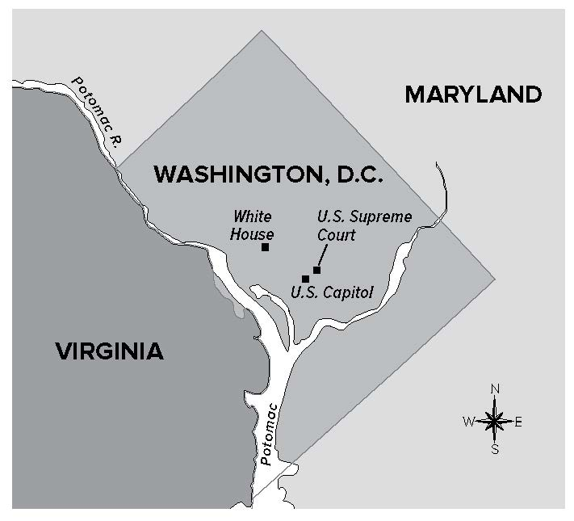

When did it happen?
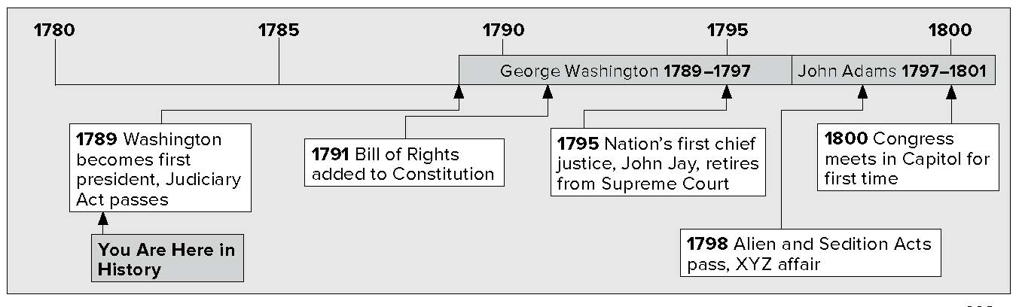

Lesson 1 The First President, Continued

Washington Takes Office
George Washington was the first president of the United States. He knew that the precedents, or traditions, he started would be important. They would shape the future of the country and the government. With Congress, Washington set up departments within the executive branch. Washington and Congress also set up the court system. Congress added the Bill of Rights to the Constitution.
The executive branch began with three departments and two offices. These advisors were called the cabinet:

Critical Thinking

- Why do you think it was important to set up a federal court system?

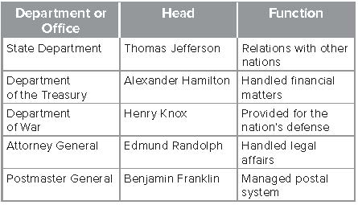

Marking the Text

- Underline the sentence that describes Washington’s first cabinet. What branch of the government is the cabinet in?

Reading Check

The Judiciary Act of 1789 created a federal court system. It had district courts at the lowest level. Courts of appeal were at the middle level. The Supreme Court was at the top of the court system. It would make the final decision on many issues. State courts and laws stayed the same. However, the federal courts had the power to change state decisions.
The first ten amendments, or changes, to the Constitution are known as the Bill of Rights. They were passed during the first meeting of Congress. The amendments limit the powers of government. They also protect the rights of the people.

The New Economy
The new United States faced serious financial problems. The national debt—the amount of money owed by the nation’s government—was very large. Alexander Hamilton was secretary of the treasury. He worked to solve the nation’s financial problems.

- What were three important actions taken by President Washington and Congress?

Lesson 1 The First President, Continued

Analyzing

- Why do you think Alexander Hamilton wanted to pay back the bonds from the confederation government?

Describing

- Why did some people oppose Hamilton’s plan to pay off government bonds?

Reading Check

- Why did Hamilton support locating the United States capital in the South?
During the Revolutionary War, the confederation government had borrowed a large amount of money. It had issued bonds. These are certificates promising to pay back money in a certain length of time. Hamilton argued that the United States should pay back money borrowed from other countries and from American citizens. Hamilton believed that the national government should also pay the war debts of the states.
Some people did not like Hamilton’s plan. Many people who bought bonds were worried that they would never be paid back. To get some money for their bonds, many people sold their bonds to speculators for less than the bonds were worth. Speculators hoped to make money later if the government finally paid back the bonds. The original bondholders saw that speculators would get rich and the bondholders would get nothing. Southern states also complained about the plan to pay state war debts. They had built up much less debt than the Northern states. They argued that the plan would make them pay more than their share.
Hamilton worked out a deal with Southern leaders. If they voted for his plan, he would support putting the new capital in the South. A new district called Washington, D.C., would be created between Virginia and Maryland.
To help build a strong national economy, Hamilton asked Congress to start a national bank. It would issue a single type of money for use in all states. Some people were against the idea, but Washington agreed with Hamilton. A national bank called the Bank of the United States was started.
Hamilton also proposed a tariff that would help protect American products. A tariff is a tax on goods bought from foreign countries. It makes products from other nations more expensive than those made at home. This tariff would help American companies compete against foreign companies.

Hamilton’s Actions
  - Paid back bonds
  - Created Bank of the United States
  - Introduced a protective tariff to help
U.S. companies
  - Supported putting the nation’s capital in the South

Lesson 1 The First President, Continued

Check for Understanding

List the 3 departments that were part of Washington’s executive branch.

Glue Foldable here

3 _____________________________________________

List 4 important actions taken by Alexander Hamilton.

7. Place a two-tab Foldable along the dotted line to cover Check for
Understanding. Write the title George Washington on the top tab and Alexander Hamilton on the bottom. On both sides of the tabs, list three things you remember about both as they helped form the new nation. Use the Foldable to help answer Check for Understanding.

