Lesson 1 The Articles of Confederation

ESSENTIAL QUESTION
Why do people form governments?

GUIDING QUESTIONS
- What kind of government was created by the Articles of Confederation?
- What process allowed new states to join the union?
- In what ways was the Confederation government weak?

Terms to Know
bicameral having two separate lawmaking organizations
republic a government in which citizens rule through elected representatives
ordinance law
depreciate lose value

Where in the world?
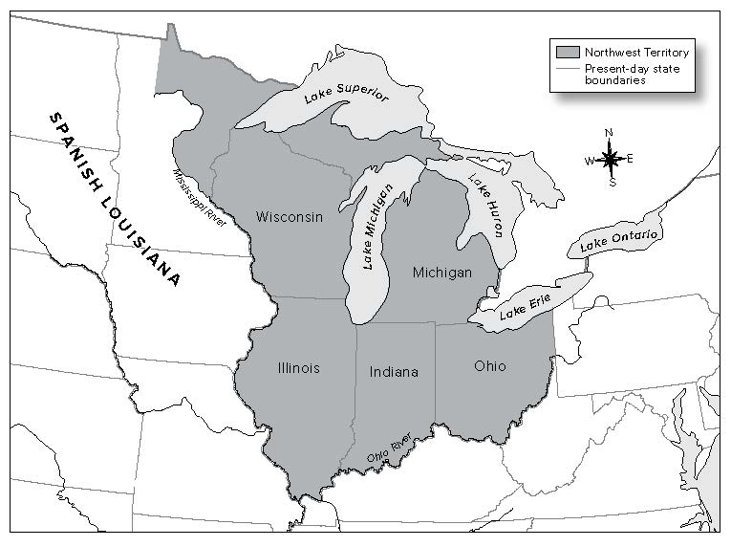

When did it happen?
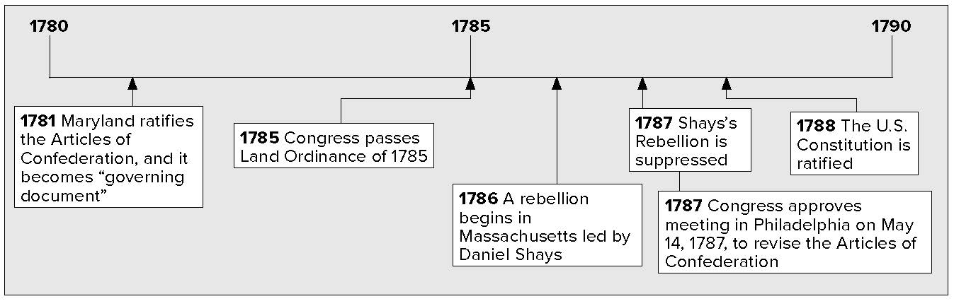

Lesson 1 The Articles of Confederation, Continued

The Making of a Republic
In May 1776, the Continental Congress asked each state to set up its government. Each state wrote a constitution. A constitution is a plan of government.
Americans did not want to give too much power to one ruler or one branch of government. State constitutions solved that problem. They split the power between the governor and legislature. The governor had less power than the legislature. Most states set up two-house, or bicameral, legislatures. This divided the power even more.
Americans had to set up a national government, too. Americans wanted their country to be a republic. In a republic, citizens elect people to represent them and make decisions based on what they want.

Mark the Text

- Underline the meaning of a constitution.

Analyzing

- What might be one result of state constitutions that limited the power of the governor?

People could not agree on what powers the national government should have. Americans felt the central government should have

only the power to fight wars and to deal with other countries.
In 1776 the Second Continental Congress had a group of people make a plan for a central government. This group created the Articles of Confederation. The Articles called for a weak central government. They also let states keep most of their powers. Congress accepted the Articles of Confederation in November, 1777.
The Articles of Confederation gave Congress certain powers, but there were important powers that Congress did not have. For example, if Congress needed to raise money or an army, it had to ask the states. The states did not have to say yes.

Mark
Powers of Congress Under
The Articles of Confederation
Congress had these powers: | Congress did NOT have these powers:
manage foreign affairs keep up armed forces borrow money  issue money | control trade  force citizens to join army impose taxes

the Text

- Circle the meaning of
republic.

Listing

- What were three weaknesses of the Articles of Confederation?

The central government did not have a chief executive. A chief executive is an official, such as a president or a governor.
A chief executive is the leader of the government and has the job of carrying out the laws. All states had to approve the Articles of

Lesson 1 The Articles of Confederation, Continued

Reading Check

- How many votes did each state have in the new Congress?

Mark

the Text

- Underline how a western district could apply to become
a state.

Reading Check

- What did the Northwest Ordinance say about slavery?
Confederation. The Articles could not be changed unless all states agreed to change it. Each state had one vote.
The states also did not agree on what to do with land in the West. Some states believed land west of the Appalachian Mountains belonged to them. Maryland did not want to approve the Articles until other states gave up claims to this land. The states finally agreed and approved the Articles. On March 1, 1781, the Articles of Confederation became the government of the United States of America.

The new national government was weak. This made it difficult for the government to handle the nation’s problems. Congress could not pass a law unless 9 states voted for it. Congress also did not have the power to change the Articles of Confederation. Any plan to change the Articles needed to be approved by all
13 states.
Even so, America’s government did some important things. America made a peace treaty with Britain. It expanded foreign trade. It set up plans for people to settle lands to the west.

Policies for Western Lands
The Articles of Confederation did not tell how to add new states. Settlers were already living west of the Appalachian Mountains. This was outside the United States. Western settlers wanted to form new states and join the Union. Congress needed to give people a way to settle the Western lands and form new states.
In 1785, the Confederation Congress passed an ordinance, or law, about western lands. This law set up a way to divide and then sell the western lands. Land was divided into townships. Land in the township was divided into smaller sections. These sections were sold to settlers.
In 1787, the Northwest Ordinance created the Northwest Territory. This territory included lands north of the Ohio River and east of the Mississippi River. The lands were divided into three to five smaller territories. A territory could apply to become a state when 60,000 people lived there. New states would have the same rights as the original 13 states. Settlers had a bill of rights. They had freedom of religion and trial by jury. The bill of rights said there could be no slavery in the Northwest Territory.
The Land Act of 1800 was passed to make it easier for people to buy land in the Northwest Territory. Some settlers did not have all of the money needed to buy land. The Act made it possible for people to pay for the land over a period of four years.

Lesson 1 The Articles of Confederation, Continued

Problems at Home and Abroad
The national government had problems paying its bills. By 1781, American dollars, called Continentals, had depreciated, or lost value. They were worth almost nothing. The War for Independence left the Continental Congress with a large debt. Congress did not have the power to raise taxes to pay these debts.
In 1781, Congress created a department of finance, led by Robert Morris. Morris made a plan to charge a 5 percent tax on goods brought in from other countries to help pay the debts. All 13 states had to approve Morris’ plan for it to pass, but Rhode Island voted no. The plan did not pass.
The new government faced other problems. The British did not let Americans trade in the West Indies and other British areas. British soldiers were still in several important forts in the Great Lakes region.

Analyzing

- Why did Robert Morris’s plan to pay the country’s war debts fail?

Reading Check

- Why did Spain close the lower Mississippi River to American shipping in 1784?

The American government had problems with Spain, too.
Spain controlled Florida and lands west of the Mississippi River. Spain wanted to stop America’s growth in Spanish territory. In
1784, Spain closed the lower Mississippi River to American shipping. Western settlers could no longer use the river for trade.
It became clear that the Confederation was not able to deal with major problems. Americans came to agree that their new country needed a stronger government.

Glue Foldable here

Check for Understanding

What kind of government was created by the Articles of Confederation?

List three problems the Confederation government faced in its relations with other countries.

- Glue a three-tab Foldable behind a two- tab Foldable along
the anchor tabs to
cover Check for Understanding.
Write Articles of
Confederation on the
anchor tab. Label the
two-tabs—Strengths, Weaknesses. Label the
three-tabs—Problems
at Home, Problems
with Britain, and
Problems with Spain.
Write two words or
phrases you remember
about each.

