Lesson 2 Forging a New Constitution

ESSENTIAL QUESTION
How do new ideas change the way people live?

GUIDING QUESTIONS
- What problems did the government face under the Articles of Confederation?
- How did leaders reshape the government?
- What compromises were reached in the new Constitution?

Terms to Know
depression a period when economic activity slows and unemployment increases manumission when a slaveholder frees an
enslaved person
proportional having the proper size in relation to other objects or items
compromise an agreement between two or more sides in which each side gives up some of what
it wants

When did it happen?

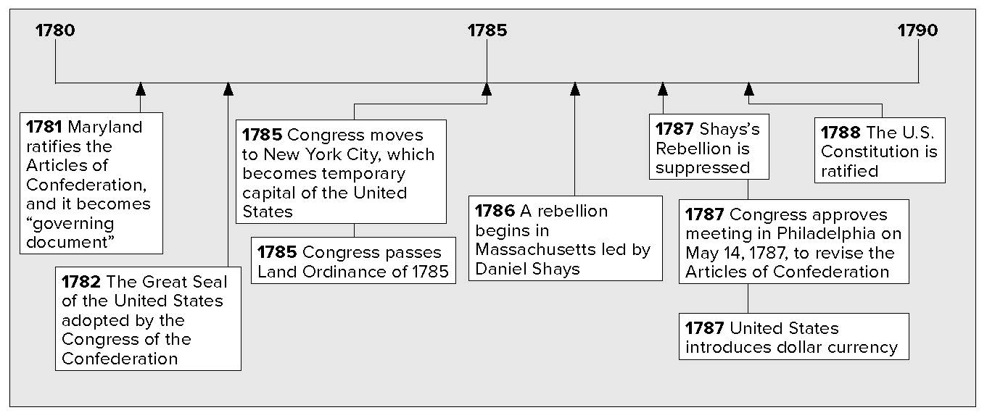

What do you know?
In the first column, answer the questions based on what you know before you study. After this lesson, complete the last column.

Now... |  | Later...
 | What was Shays’s Rebellion?
 | What was the Constitutional Convention?
 | What was the Great Compromise?

Lesson 2 Forging a New Constitution, Continued

The Need for Change
The Articles of Confederation created a weak national government. This made it difficult for the government to deal with the nation’s problems. The United States went through a depression after the American Revolution. A depression is a period of time when business slows down and many people lose their jobs.
The government had little money. The money it had was used to pay debts, or money owed, to foreign countries. There was not enough money in the United States.
The slow economy meant farmers sold less of their goods. Some farmers could not pay taxes and other debts. As a result, state officials took over their land and put many of them in jail. Farmers grew angry over this treatment.
In 1787, Daniel Shays led a group of angry farmers to a weapons storehouse in Springfield, Massachusetts. The farmers wanted to take guns and bullets. The state militia ordered the

Mark

the Text

- Underline the meaning of depression.

Reading Check

- Why did farmers in Massachusetts rebel in 1787?

farmers to stop. They fired their guns into the air. The farmers did not stop. The militia fired again and killed four farmers. Shays and
his followers ran away. The rebellion ended. Americans were worried that the government could not prevent violence.

Shays’s Rebellion of 1787

Shays led 1,200
farmers to federal arsenal for guns
State militia ordered farmers
to stop; fired into the air
State militia shot four farmers
Farmers fled

Identifying

- Name three ways in which free African Americans faced discrimination.

The American Revolution was based on freedom. This caused some Americans to believe that slavery should be outlawed. Several northern states began passing laws to end slavery. Free African Americans faced discrimination even in states that did not have slavery. They were not allowed to go to many public places. Few states gave them the right to vote. The children of most free African Americans could not go to school with white children.
Some slaveholders freed their slaves after the American

Defining

4. What was
manumission?

Revolution. Virginia passed a law that encouraged manumission, the freeing of individual enslaved persons. The number of free
African Americans grew in that state. Even with these efforts, slavery was still a key part of life in Southern states. Southern plantations depended on slave labor. Many white Southerners

Lesson 2 Forging a New Constitution, Continued

were afraid that their economic system would die without slavery. The issue of slavery began to divide Northerners and Southerners.

The American Revolution and Slavery

North |  | South
American Revolution led to gradual end of slavery in the North. |  | Economy in South continued to depend heavily on slave labor.

Analyzing

- Why was it important for the American people to trust the work of the Constitutional Convention?

Identifying

- How many representatives would each state have under the Virginia Plan?

Reading Check

- Why did New Jersey’s delegates object to the Virginia Plan?

The Constitutional Convention
The American Revolution had not created a united country. Some leaders liked strong, independent state governments. Other leaders wanted a strong national government. They wanted to change the Articles of Confederation. Two of these leaders were James Madison and Alexander Hamilton.
In September 1786, Hamilton called for a convention in Philadelphia to talk about trade issues. He also suggested that people at the convention should talk about how to change the Articles of Confederation.
The convention began in May 1787. George Washington and Benjamin Franklin were among those who attended. This helped people trust the convention’s work. Trust was important because the convention’s purpose was to create an entirely new constitution. The delegates chose George Washington to lead the meetings.
Edmund Randolph of Virginia surprised the delegates at the convention. He proposed a plan created by James Madison, called the Virginia Plan. The Virginia plan would set up a strong national government. It would create a government with three branches. There would be a two-house legislature, a chief executive chosen by the legislature, and a court system.
The plan also called for the number of members in both houses of the legislature to be proportional. The number of members would be based on each state’s population. States with more people would have more representatives than states with fewer people.
Delegates from small states were against the Virginia Plan. They wanted all states to have equal representation. They supported the New Jersey Plan. Under the New Jersey plan, the legislature would be a one-house legislature. Each state would have one vote in the legislature.

Lesson 2 Forging a New Constitution, Continued

Agreeing to Compromise
The delegates agreed to create a new constitution based on the Virginia Plan. The delegates still needed to deal with the issue of representation.
Roger Sherman came up with an agreement called the Great Compromise. A compromise is an agreement between two or more sides. Each side gives up some of what it wants. The Great Compromise called for a two-house legislature. Each state would

Reading Check

- What compromises were made on the issue of slavery?

have two members in the Senate. The number of members in the House of Representatives would be based on the size of each
state’s population.
Southern states wanted to count enslaved people as part of their population. This would raise their population. It would give them more seats in Congress, and it would raise their taxes. Northern states did not want the South to count its enslaved people. The delegates agreed to the Three-Fifths Compromise. Each enslaved person would count as three-fifths of a free person. Northerners also agreed not to block the slave trade until 1808.
George Mason wanted more protection for citizens’ rights. He asked for a bill of rights to part of the Constitution. Many

delegates felt that the Constitution already protected people’s rights.
On September 17, 1787, the delegates gathered to sign the new Constitution. The Constitution was then sent to the states for approval. The new Constitution would take effect when 9 of the 13 states approved it.

Glue Foldable here

Check for Understanding

List the three branches of government created by the new Constitution.

What two things did the delegates disagree about that forced them to make compromises?
- Place a two-tab
Foldable along the dotted line to cover Check for
Understanding. Write
the title Constitutional Convention on the
anchor tab. Label the
two tabs—Agreed and Disagreed. Recall and
write about issues of agreement and disagreement. Use
your notes to help
answer the Check for Understanding.

