Lesson 3 A New Plan of Government

ESSENTIAL QUESTION

How do governments change?

GUIDING QUESTIONS
- From where did the Framers of the Constitution borrow their ideas about government?
- How does the Constitution limit the power of the government?
- How was the Constitution ratified?

Terms to Know
federalism sharing power between the federal and state governments
legislative branch lawmaking branch of government
executive branch branch of government headed by the president
Electoral College group chosen by each state to vote for president and vice president
judicial branch branch of government made up of courts that settle questions of law and disagreements
amendment a change, correction, or improvement added to a document
checks and balances system in which the
branches of government can limit each others’
powers

When did it happen?
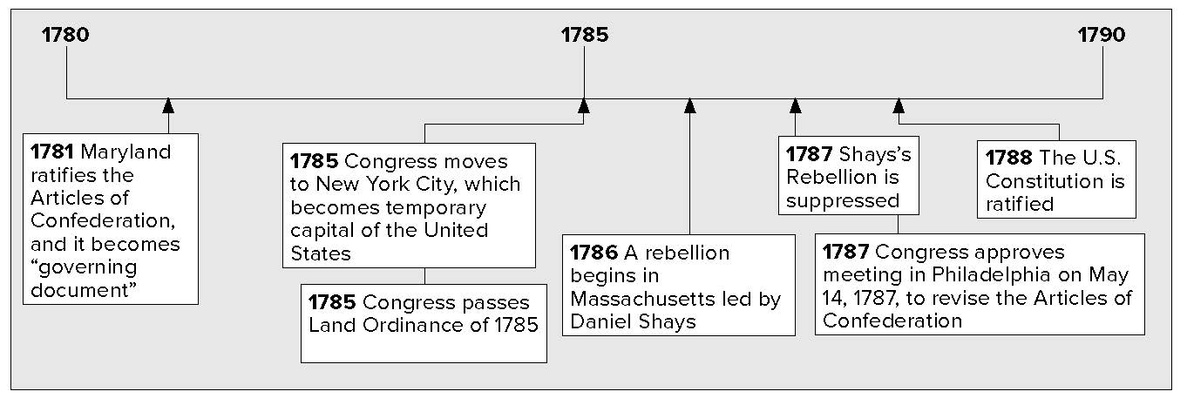

What do you know?
In the first column, answer the questions based on what you know before you study. After this lesson, complete the last column.

Now... |  | Later...
 | What gave American delegates some of their ideas for the Constitution?
 | What are the three branches of government?
 | What does it mean to ratify the Constitution?

Lesson 3 A New Plan of Government, Continued

The Constitution’s Sources
The delegates in Philadelphia created a new constitution. The delegates liked ideas from European political groups and writers. Some of these ideas are in the Constitution.
Even though Americans broke away from Britain, they still respected many British traditions. Traditions are cultural ideas and practices. Individual rights are part of the British system. The Framers of the Constitution felt it was important to have individual rights.
An English law, the Magna Carta, limited the power of the king or queen. He or she had to accept the laws of the lawmaking body. The lawmaking body paid for wars and the royal government. American colonies worked the same way. American lawmaking bodies controlled their colonies’ funds. They also had some control over colonial governors.

Marking the Text

- Underline the sources, or starting places, of many ideas in the Constitution.

Magna Carta as a Model

English lawmaking body

Controlled some of ruler’s money

American colonial assemblies
Controlled some of governor’s money

The British also came up with the English Bill of Rights in 1689. Many Americans liked the idea of having a bill of rights. Some felt that a bill of rights needed to be included with the Constitution.
The Framers of the Constitution believed in the ideas of some European writers. Two of these writers were John Locke and Baron de Montesquieu (MAHN • tuhs • KYOO).
The English writer, Locke, believed that all people have natural rights. These rights include the rights to life, liberty, and property. Locke wrote that government is based on an agreement, or contract. This agreement is between the people and the ruler. The Constitution would also be a contract. It would limit the government’s power. This would help protect people’s natural rights.
Montesquieu was a French writer. He believed that the government’s power should be divided and balanced. This would make it difficult for one person or group to have too much power. The Framers of the American Constitution carefully described and divided the powers of government.
The Articles of Confederation had given most power to the states. The Constitution changed this. States had to give up some

Identifying

- According to Locke, what are the three natural rights that all people have?

Lesson 3 A New Plan of Government, Continued

Identifying

- List three powers the
U.S. Constitution gives to the states.

Reading Check

- What is federalism?

Marking the Text

- Circle the three branches of government.

Defining

- What is the Electoral College?
of their powers to the federal, or national, government. The Constitution was set up so federal and state governments share power. This is called Federalism.
The Constitution gave new powers to the federal government. It could tax, manage trade, control the supply of money, form an army, and declare war. The federal government could pass laws it decided were “necessary and proper.”
The Constitution let states keep some important powers. The states could still control trade inside their borders. They had the power to set up local governments and schools. States also made laws about marriage and divorce.
The Constitution allows some powers to be shared by the federal and state governments. Both the federal and state governments may tax their citizens. Both governments may arrest and punish criminals.
The Constitution is the supreme, or highest, law of the land. Any disagreement between the federal government and the states was to be settled by the federal courts. They make decisions based on what the Constitution says.

Government Structure
The Framers of the Constitution divided the federal government into three branches. These are the legislative, executive, and judicial branches. The first three articles, or sections, of the Constitution explain the powers and tasks of these branches of the federal government.
Article I says the legislative (LEH • juhs • lay • tiv) branch, or lawmaking branch of the federal government is Congress. Congress has two parts: the Senate and the House of Representatives. Congress’s powers include such tasks as deciding how much taxes will be, minting coins, and controlling trade.
Article II describes the executive branch. The president is in charge of this branch. The president’s job is to carry out the nation’s laws. A group called the Electoral (ee • lehk • TAWR • uhl) College elects the president and vice president. Its members are called electors. Electors are chosen by the voters of each state.
Article III describes the judicial ( joo • DIH • shuhl) branch, or the court system. The Supreme Court is the top court in the nation. Congress sets up federal courts under the Supreme Court. Federal courts make decisions on cases that have to do with the

Lesson 3 A New Plan of Government, Continued

Constitution, with federal laws, and with problems between states.
The Framers built in a system of checks and balances. Each branch of government has ways to check, or limit, the power of the others. This way, no branch can have too much control in the government.

Debate and Adoption
The Constitution could take effect after nine states ratified, or approved, it. People who supported the Constitution were called Federalists. James Madison, Alexander Hamilton, and John Jay were among the Federalists. They wrote a set of essays, called the Federalist Papers. The Federalist Papers explained and defended the Constitution.
People who did not like the new Constitution were called Anti- Federalists. They were afraid that a strong national government would take away freedoms. Anti-Federalists wanted local governments to have more power.
By June 21, 1788, the ninth state ratified the Constitution. That meant the new government could go into effect. New York and Virginia, the two largest states, still had not approved the Constitution.
People worried that the new government would not succeed if those states did not ratify the Constitution. Virginia ratified after it was promised that there would be a bill of rights amendment. The Bill of Rights was added in 1791. New York, North Carolina, and Rhode Island also ratified the Consititution.

Check for Understanding
Explain the principle of Federalism.
Glue Foldable here

Why is the system of checks and balances important?

Reading Check

- How is power divided among the branches of government?

Reading Check

- Why was it important that the largest states ratify the constitution?

- Place a three-tab Venn diagram Foldable
along the line to
cover Check for Understanding. Write A New Plan for Government on the anchor tab. Label the tabs—Federal Government, Shared Powers, and State Government. On both sides of the tabs, list facts about each
to compare the federal and state
governments. Use your notes to help answer the questions below
the tabs.

